

Graduation Project

Intelligent Mixed Reality Navigation Assistant for Smart Buildings with Multimodal AI Integration
(CEREBRO)

Submitted By
Team

- Ahmed Mohamed Moussa - 222101392
- Sandy Samy Samir – 222101524
- Basma Ahmed Mahmoud - 221101164

Supervised by:

Associate Professor. Aya Zoghby
Dr. Waleed Mohamed
Dr.Mohamed Handosa

Faculty of Computer Science and Engineering
New Mansoura University
2025-2026

Graduation Project

CEREBRO

Submitted By
Team
Student Name | Student Academic ID | Program | Track
Ahmed Mohamed Moussa | 222101392 | AIS
Sandy Samy Samir | 222101524 | AIS
Basma Ahmed Mahmoud | 221101164 | AIE

ABSTRACT
Modern wearable technologies aim to enhance human–technology interaction; however, current smart glasses solutions remain limited in personalization, contextual awareness, and seamless multimodal integration. To address these limitations, we present an advanced AI-powered smart glasses system designed to improve daily communication, productivity, accessibility, and decision-making through intelligent, hands-free interaction.

The smart glasses integrate a wide range of cutting-edge technologies, including speech recognition, real-time multilingual translation, large language models, computer vision, augmented reality, GPS navigation, environmental sensing, and smart home connectivity. The system enables users to communicate across language barriers, record audio and video, capture images, take notes, browse the web, and access contextual information through a built-in heads-up display (HUD).

A YOLO11-based computer vision module, trained on custom datasets, performs real-time object detection and face recognition, allowing the system to identify members of the user’s social circle and personalize interactions. Navigation is supported through a custom indoor GPS solution that combines manually mapped building layouts, graph-based routing, and Wi-Fi triangulation to deliver accurate guidance in complex indoor environments.

The speech interaction pipeline utilizes Whisper for Arabic and English transcription, which is processed by a large language model to interpret user intent and generate structured JSON-based task instructions. Responses are delivered through a multilingual text-to-speech engine, ensuring natural and context-aware interaction in the user’s preferred language. The hardware architecture is centered around an ESP32 module, providing Bluetooth and Wi-Fi connectivity to microphones, speakers, sensors, and the smart glasses interface.

A responsive mobile application and web dashboard complement the smart glasses by enabling smart home control, device management, analytics, and accessibility customization. The platform supports real-time data synchronization, user preferences, and system monitoring, and can function independently of the glasses for broader accessibility. The system is designed with inclusivity as a core principle, offering voice commands, haptic feedback, visual aids, and personalized assistance for users with disabilities or mobility challenges. It also enhances driver safety by minimizing manual interaction and improving navigation awareness.

This project delivers a modular, scalable, and future-ready smart glasses platform that leverages AI, AR, and multimodal human interaction to enhance daily life across education, healthcare, business, travel, and customer service domains. In addition, a comprehensive competitor analysis of Amazon Echo Frames and Meta Ray-Ban glasses highlights the technological gaps addressed by our system, particularly in advanced computer vision, indoor navigation, smart home integration, and AI-driven personalization.

ACKNOWLEDGEMENTS
We would like to express our heartfelt and deepest gratitude to everyone who stood by our side and supported us throughout the journey of this project.
First and foremost, we extend our sincere thanks to our beloved supervisor, Dr. Aya Zoghby, whose wisdom, patience, and heartfelt support have made a lasting impact on both our project and our personal growth. Her tireless guidance and unwavering dedication were lights that guided us through every challenge we faced.
A special and warm thank you to New Mansoura University, whose unwavering support, encouragement, and belief in our potential have been a cornerstone of our progress.
We are truly honored and grateful to Prof. Dr. Moawad El-Kholy, President of the University, for his visionary leadership and continuous inspiration, which have always motivated us to aim higher and work harder.
Our heartfelt appreciation goes to Prof. Dr. Khaled Fouad, Dean of the Faculty of Computer Science and Engineering, for his steadfast support, kind guidance, and genuine care. His presence throughout this journey has been a true source of strength and motivation.
We also extend our sincere thanks to Dr. Mohamed Handosa & Dr. Waleed Mohamed for their close follow-ups, thoughtful suggestions, and constructive feedback. Their insightful remarks played a vital role in refining and improving the quality of our work.
We would also like to thank all the faculty members who enriched us with knowledge and helped shape our academic and professional identities. Their passion for education and excellence continues to inspire us every day.
Finally, we owe an immense debt of gratitude to our families, who stood by us with love, prayers, and encouragement in every step of the way. Their belief in us gave us the strength to move forward, even in the toughest moments.
And to our incredible teammates, thank you for your dedication, support, and shared dreams. Even though you did not continue the vision with us. This achievement would not have been possible without your collaboration and determination.
This project is not just a result of effort and time. It reflects the support, love, and belief of all those who walked with us along this journey.

TABLE OF CONTENTS
ABSTRACT I
ACKNOWLEDGEMENTS III
TABLE OF CONTENTS IV
LIST OF TABLES VI
LIST OF FIGURES VII
SYMBOLS & ABBREVIATIONS VIII
1. INTRODUCTION 1
1.1. Problem Statement 1
1.2. Project Purpose 1
1.3. Project Scope 1
1.4. Objectives and Success Criteria of the Project 1
1.5. Report Outline 1
2. RELATED WORK 2
2.1. Existing Systems 2
2.2. Overall Problems of Existing Systems 2
2.3. Comparison Between Existing and Proposed Method 2
3. METHODOLOGY 3
3.1. Requirement Analysis 3
3.2. Design 3
3.3. Implementation 3
3.4. Testing 3
3.1. Overview of the Dataset/Model 3
3.2. Tools and Technology 3
3.3. Proposed Approach 3
3.1. Design Overview 4
3.2. System Architecture 4
3.2.1. Module A 4
3.2.2. Module B (and more, if necessary) 4
3.3. System Software 4
4. EXPERIMENTAL RESULTS 5
5. DISCUSSION 6
6. CONCLUSIONS 7
REFERENCES 8
APPENDIX 9

LIST OF TABLES
ABSTRACT 1
TABLE OF CONTENTS 2
LIST OF TABLES 4
1. INTRODUCTION 1
1.1. Problem Statement 1
1.2. Project Purpose 1
1.3. Project Scope 2
1.4. Objectives and Success Criteria of the Project 3
1.5. Report Outline 9
2. RELATED WORK 12
2.1. Existing Systems 12
2.2. Overall Problems of Existing Systems 14
2.3. Comparison Between Existing and Proposed Method 16
Table 2.1: Comparison of methods 16
Table 2.2: Comparison of products 17
3. METHODOLOGY 25
3.1. Requirement Analysis 25
UC1 – Real-Time Object Detection 54
UC2 – Indoor Navigation 54
UC3 – Smart Home Control 54
3.2. Design 55
3.3. Implementation 55
3.4. Testing 55
3.1. Overview of the Dataset/Model 55
3.2. Tools and Technology 55
3.3. Proposed Approach 55
3.1. Design Overview 56
1. Vision Dataset Collection 56
2. Floor Map Data for Indoor Navigation 56
3. Speech Dataset 56
3.3. System Software 62
4. EXPERIMENTAL RESULTS 63
5. DISCUSSION 64
6. CONCLUSIONS 65
REFERENCES 66
APPENDIX 67

INTRODUCTION

Problem Statement
In today’s fast-paced world, technology has become an integral part of daily life. However, users face several challenges when interacting with various technological devices, particularly in daily communication, productivity, and navigation. Key problems include:

- Language Barriers: Users often struggle to communicate effectively due to differences in spoken or written language, especially in international environments or while traveling.
- Task Distraction: Managing multiple tasks at once—such as note-taking, capturing photos, recording audio, or checking messages—can overwhelm users and reduce efficiency.
- Lack of Intelligent Assistance: Most devices do not provide a personal smart companion capable of understanding user needs and offering real-time guidance.
- Indoor Navigation Limitations: In large or complex buildings like universities, hospitals, or corporate campuses, finding the desired destination can be difficult without accurate navigation support.

The proposed system, Smart Glasses, addresses these challenges by combining AI-driven smart assistance, speech recognition, real-time translation, augmented reality, indoor navigation, and environmental and health monitoring sensors into a single portable and ergonomic device.

Project Purpose
The primary goal of the Smart Glasses project is to create a productive, intelligent, and user-friendly environment that enhances daily life by:

- Enabling seamless hands-free communication through speech recognition and translation features.
- Providing a smart companion capable of understanding tasks, managing schedules, setting reminders, and offering personalized recommendations.
- Improving navigation in complex indoor and outdoor environments using GPS, computer vision, and graph-based pathfinding algorithms.
- Supporting users with disabilities through voice commands, visual aids, haptic feedback, and gesture recognition.
- Allowing immersive experiences with augmented reality overlays for both productivity and entertainment purposes.
- Continuously adapting to user behavior using machine learning algorithms for personalized interaction and decision support.

The project aims to reduce daily friction, enhance productivity, and improve the overall quality of life, providing a comprehensive solution that integrates communication, navigation, health monitoring, and intelligent assistance in one device.

Project Scope
The scope of the Smart Glasses project includes:

- Hardware Development:

- Wearable device platform with microphone, speakers, camera, display, and sensors.
- GPS module for location-based services and indoor positioning.
- Low-latency wireless connectivity (Wi-Fi, Bluetooth).

- Software Development:

- Speech recognition and text-to-speech (TTS) systems.
- Natural Language Processing (NLP) for task understanding.
- AI-powered smart companion for scheduling, reminders, and assistance.
- Machine learning models for adaptive and personalized user experience.
- Augmented reality interface for immersive visualization and interaction.
- Web browsing and dashboard interface for remote management.

- User Interaction Features:

- Hands-free operation with voice commands and gesture recognition.
- Real-time translation for multiple languages.
- Environmental and health monitoring with alerts and recommendations.
- Seamless communication with loved ones.

The project is designed to cater to a wide range of use cases including education, healthcare, business, entertainment, travel, customer service, and accessibility for users with disabilities.

Objectives and Success Criteria of the Project
Project Objectives (expanded)

- Enhance Communication

Provide robust real-time transcription and translation to remove language friction in live conversations and recorded media.

What this means: Continuous low-latency speech-to-text (STT) in the user’s active language, with optional simultaneous translation into a target language; support for multi-speaker scenarios and punctuation/formatting in transcripts.

Implementation notes: Use an on-device or hybrid STT pipeline (edge model + cloud fallback) with language detection, speaker diarization (who spoke when), and punctuation restoration. Post-process with NER & context-aware normalization for names, dates, and domain terms.

- Improve Daily Productivity
Enable multitasking by letting users capture notes, voice memos, photos and video, and quickly retrieve contextual information via HUD and voice/gesture controls.

What this means: Voice/gesture-triggered note-taking, automatic summarization of recorded meetings, fast media capture (single-command photo/video), and searchable transcripts synchronized with timestamps.

- Provide Smart Assistance
Build an AI companion that understands context, follows multi-turn dialogues, manages schedules, sets reminders, answers queries, and provides empathic micro-interactions.

What this means: Context retention across sessions (short-term and long-term), calendar/notification integration, task suggestions, and safe emotional-support responses (non-clinical).

- Enable Accurate Navigation
Combine GPS (outdoor) and Indoor Positioning Systems (IPS) using camera-based positioning (visual localization), Wi-Fi/BLE triangulation, and graph-based path planning for reliable route guidance.

What this means: Outdoor turn-by-turn guidance plus indoor floor-plan localization with visual anchors, map matching, and shortest-path recommendations tailored to user preferences (e.g., step-free routes).

- Ensure Accessibility
Design for inclusive use: voice commands, speech-to-text for deaf/hard-of-hearing users, text-to-speech for low-vision users, haptic feedback, and interaction alternatives to touch.

What this means: Multiple input/output modalities, adjustable font/UI scaling on HUD, caption customization, and integrations with hearing aids/assistive devices.

- Offer Immersive AR Experiences
Overlay contextual, relevant information on the user’s view (POI labels, navigation arrows, object labels, safety warnings) to improve situational awareness without cluttering the display.

What this means: Minimalist HUD design, context-aware content prioritization, and adaptive layering (show/hide based on user focus).

- Continuously Adapt
Use machine learning to personalize behaviour and improve feature accuracy based on user interactions and anonymized usage patterns.

What this means: On-device fine-tuning / federated learning where appropriate, adaptive speech models for user accents, and personalization of recommendations and UI.

Success Criteria (expanded & measurable)

These are measurable acceptance criteria the project must meet to be considered successful:

- System Reliability & Integration

- All hardware and software components must operate without critical failures during a standard 8-hour mixed-use scenario (recording, navigation, calls, AR use).
- Metric: < 2% system-crash rate per 100 user-hours; mean time between failures (MTBF) ≥ target.

- Speech Recognition & Translation Accuracy

- Metric (speech): Word Error Rate (WER) ≤ 12% in quiet environments, WER ≤ 20% in noisy environments (street/cafe).
- Metric (translation): BLEU/chrF comparable to baseline production translation (expected acceptable threshold: intelligible, with >80% user-rated adequacy in evaluations).
- Evaluation: Use standard datasets for benchmarking and controlled user studies with native speakers for subjective ratings.

- Navigation & IPS Performance

- Outdoor: GPS-guided routing with arrival error ≤ 5 m under normal conditions.
- Indoor: Localization accuracy ≤ 2–3 m in mapped indoor spaces; path guidance success rate ≥ 90% for target destinations (in tested buildings).
- Evaluation: Field tests in multiple indoor environments, measuring localization error and successful arrival rate.

- Latency & Responsiveness

- Voice command latency (voice → action) ≤ 1.0 s for on-device actions; transcription streaming latency ≤ 500–800 ms (per chunk).
- AR overlay update rate ≥ 30 FPS nominal for smooth visuals.
- Evaluation: Automated profiling + real-world user latency tests.

- Usability, Comfort & Acceptance

- Metric: System must achieve an average SUS (System Usability Scale) score ≥ 70 in pilot studies and positive qualitative feedback on comfort for at least 80% of test participants wearing the device for 1 hour.
- Evaluation: Usability tests, comfort questionnaires, and cognitive-load assessments.

- Accessibility Effectiveness

- Provide configurable captioning and TTS with user satisfaction ≥ 80% among participants with relevant disabilities in targeted trials.
- Support alternative input (gesture, physical buttons) with ≥ 90% task-completion rate in accessibility-focused tasks.

- Privacy & Security

- Sensitive personal data processed locally by default; cloud storage uses end-to-end encryption and explicit user consent.
- Metric: No critical privacy violations in penetration test; compliance checks (documented flow of sensitive data).

- Continuous Improvement

- Measurable improvement in at least one personalization metric (e.g., speech recognition WER for the user) after 4 weeks of adaptive usage.
- Evaluation: Compare pre- and post-adaptation model metrics.

Domain-Specific Additions (Education, Travel, Accessibility)

Below are expanded details and success criteria for the three domains you asked to add.

- Education — Features, Use Cases & Success Criteria

Key features for education use-cases

- Live lecture transcription with speaker diarization and timestamped notes.
- Real-time translation for multilingual classrooms.
- Live summarization and study-guide generation after class.
- AR overlays for visual aids (labeling diagrams, 3D models).
- Hands-free photo capture of whiteboards + auto-enhanced cropping.

Example user flows

- Student activates “Lecture Mode” → device records audio, displays live captions on HUD, and marks important moments when the student says “mark” or uses a gesture → after class, AI generates a summary and suggested study flashcards.

Education success criteria

- Lecture transcription WER ≤ 10% in lecture hall conditions.
- Automated summarization scores (ROUGE/BLEU-like proxy) reach acceptable readability in educator review (> 80% acceptability).
- Student acceptance: ≥ 75% of pilot students find generated notes usable for studying.

Implementation notes

- Use domain-adaptive language models for educational vocabulary (STEM terms).
- Provide export to common LMS formats (PDF, DOCX, CSV of timestamps).

- Travel — Features, Use Cases & Success Criteria

Key features for travel

- Turn-by-turn outdoor navigation via GPS with HUD arrows and voice prompts.
- Indoor navigation in transit hubs (airports, malls) using IPS + CV anchors.
- Real-time POI labeling and quick translation assistance in conversations with locals.
- Travel-safety overlays: hazard warnings, environment alerts (e.g., high temperature).

Example user flows

- Tourist enables “Travel Mode” → device shows route overlays on HUD, reads next steps aloud, and suggests POIs nearby based on user preferences; in foreign language interactions, automatic live translation is offered.

Travel success criteria

- Outdoor navigation arrival error ≤ 5 m; route-follow success ≥ 90%.
- Indoor localization median error ≤ 3 m across tested transit hubs.
- At least 85% user satisfaction in pilot travel scenarios (usability, safety, helpfulness).

Implementation notes

- Provide offline maps and cached translations for areas with poor connectivity.
- Prioritize low-latency voice translation for conversational use.

- Accessibility for Users with Disabilities — Features, Use Cases & Success Criteria

Key accessibility features

- For deaf/hard-of-hearing: Live captions, speaker diarization, transcript export, vibrational/haptic alerts for incoming calls/events.
- For low-vision: Clear TTS, high-contrast HUD mode, audio scene descriptions (object labels read aloud).

- For motor impairments: Full voice and gesture alternatives; customizable single-gesture triggers; physical button fallback.
- Cognitive accessibility: Simplified UI mode, step-by-step guidance, and context reminders.

Example user flows

- A deaf user attends a family gathering: device displays live captions for multiple speakers and marks each speaker with a name when recognized.
- A visually impaired user navigates a crowded station: device announces upcoming turns and nearby POIs, and warns about obstacles.

Accessibility success criteria

- Caption accuracy and readability judged acceptable by ≥ 80% of participants with hearing impairments.
- TTS naturalness & clarity rated ≥ 4/5 by visually impaired testers.
- Alternative input methods achieve ≥ 90% task-completion rate for key actions across users with motor impairments.

Implementation notes

- Co-design with accessibility experts and users with disabilities during prototyping.
- Provide robust customization (font size, speech rate, haptic intensity, color schemes).

Evaluation & Testing Plan (brief)

- Benchmarks & Lab Tests

- Evaluate STT, translation, object detection (mAP), and localization on standard datasets and synthetic noisy conditions.
- Measure latency, FPS, battery, and thermal performance in controlled lab runs.

- Field Trials

- Multi-scenario field tests (indoor venues, streets, transit hubs, classrooms). Collect telemetry, logs, and objective metrics.

- User Studies

- Usability studies (SUS), domain-specific trials for Education/Travel/Accessibility, and qualitative interviews.

- Security & Privacy Audits

- Threat modeling, penetration testing, and privacy impact assessment.

- Iterative Improvements

- Use pilot feedback and logged metrics to prioritize fixes; re-evaluate acceptance metrics after 2–4 sprint cycles.

Deliverables (related to Objectives and Success Criteria)

- Functional prototype with: STT + translation, HUD overlay, object detection demo (YOLO11), indoor/outdoor navigation demo, and basic smart companion features.
- Evaluation report with benchmark numbers (WER, localization error, SUS scores).
- Accessibility compliance checklist and pilot study results.
- Privacy & security documentation (data flow diagrams + consent UX).

Report Outline
2. RELATED WORK
This chapter explores the background research and technologies that form the foundation of the Smart Glasses System. The project integrates multiple fields—computer vision, indoor navigation, wearable hardware, natural language processing, intelligent speech interaction, smart home automation, and multimodal user interfaces. To provide a comprehensive review, this chapter examines existing systems, identifies their limitations, evaluates competitor technologies, and highlights the gaps addressed by the proposed solution.

Existing Systems
Comparison with:
Cerebro , hololens , Meta Ray-Ban Glasses and Amazon Amelia Smart Glasses 4

- Microsoft HoloLens

Overview

HoloLens is a high-end Mixed Reality (MR) headset designed mainly for industrial, medical, and engineering environments. It offers advanced holographic projection, spatial mapping, and hand/eye tracking.

Strengths
- Industry-grade holograms and spatial mapping
- Accurate hand and eye tracking
- Suitable for training, simulation, and engineering visualization
- Stand-alone computing with no external device needed

Weaknesses
- Heavy and not comfortable for daily, long-term use
- Very expensive
- Limited battery life under continuous MR use
- Not optimized for real-time translation or lightweight everyday tasks

- Meta Ray-Ban Smart Glasses

Overview

Meta Ray-Ban focuses on lifestyle use: capturing photos, recording videos, making calls, and using Meta AI through voice commands.

Strengths
- Stylish, socially acceptable design
- High-quality camera and audio system
- Good battery life for light use
- Strong voice assistant through Meta AI

Weaknesses
- No visual display or HUD
- No AR overlays
- Limited on-device AI processing
- Not built for navigation, translation, or object understanding

- Amazon Amelia / Amazon Echo Frames

Overview

Amazon’s glasses are voice-first devices built mainly around Alexa interactions. They emphasize audio tasks and smart home control rather than visual computing.

Strengths
- Excellent voice assistant (Alexa)
- Lightweight and comfortable
- Strong integration with smart home features
- Good for reminders, calls, and simple everyday tasks

Weaknesses
- No screen, HUD, or visual interface
- No camera or computer vision
- No AR or visual overlays
- Heavy dependence on cloud processing

Final Comparison Summary:

Feature | Our Smart Glasses (Cerebro) | HoloLens | Meta Ray-Ban | Amazon Amelia
Daily Comfort | High | Low | High | High
Display | HUD + AR | Full MR | None | None
Object Detection | Yes (built-in) | With customization | Basic | No
Indoor Navigation | Yes | No | No | No
Translation | Real-time | No | No | No
Social AI (faces, memory) | Yes | Very limited | No | No
On-Device Processing | Yes | Yes | Limited | Limited
Target Use | Everyday AI assistant + AR navigation | Industrial MR | Lifestyle | Voice assistant

Existing wearable and smart assistant technologies focus primarily on isolated functionalities. They offer speech interaction or augmented reality, but few combine multimodal AI capabilities in one consistent and user-friendly system.

2.1.1 Amazon Amelia Smart Glasses

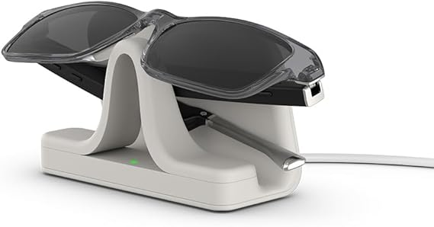
Figure 2.1: Amazon Amelia Smart Glasses (Amazon Echo Frames) – smart glasses with integrated voice assistant.(Source: Amazon official product page)

Amazon Amelia Smart Glasses are AI-powered smart glasses designed primarily for voice-based interaction through an integrated virtual assistant. The system focuses on productivity tasks, reminders, and hands-free voice commands, targeting lightweight daily assistance rather than advanced visual intelligence.

• Designed as AI-powered smart glasses with integrated voice assistant “Amelia.”
• Focused mainly on voice-based interaction, reminders, and productivity tasks.
• Offer basic multimodal support (voice + simple visual cues), but no advanced computer vision.
• No built-in object detection, scene understanding, or real-time AR processing.
• Limited navigation support — no indoor mapping or route guidance.
• No advanced AI reasoning beyond cloud-based responses.
• Do not support AR overlays on the real-world environment.
• Smart home integration is minimal and voice-only.

Limitations:
Amelia Smart Glasses lack computer vision, AR overlays, indoor navigation, context-aware AI reasoning, and multimodal perception, making them less capable for education, accessibility, or complex travel assistance.

2.1.2 HoloLens 2

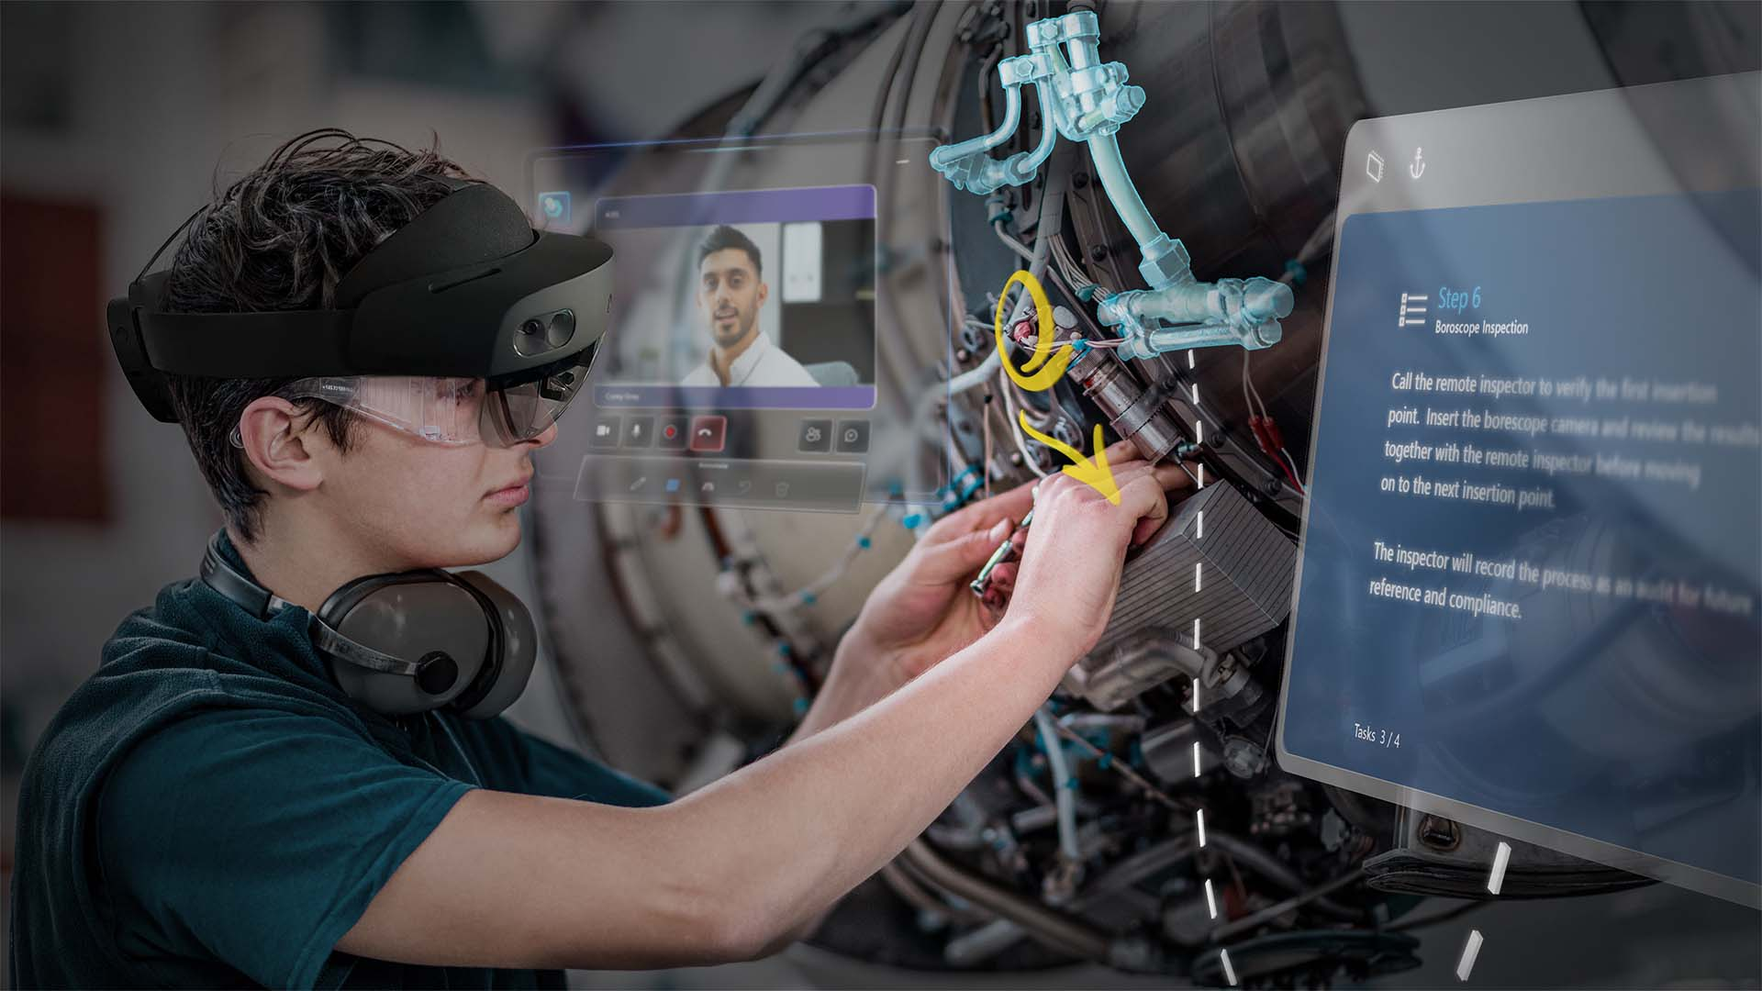
Figure 2.2: Microsoft HoloLens 2 mixed reality headset.
(Source: Microsoft official product page).

Microsoft HoloLens 2 is an advanced mixed reality headset developed by Microsoft, designed to overlay digital holograms onto the real-world environment. It is primarily targeted toward industrial, medical, and enterprise applications that require spatial mapping and immersive augmented reality interaction.

• Advanced mixed reality headset with full AR overlays and spatial mapping.
• Supports hand tracking, eye tracking, and holographic interaction.
• Offers strong computer vision but optimized mostly for industrial and medical applications.
• Bulky form factor — not suitable for everyday travel, campus use, or continuous wear.
• Limited outdoor usability due to sunlight reflection and heavy optics.
• No built-in indoor navigation for public buildings (requires enterprise-level setup).
• Very expensive, not consumer-friendly, and not designed for accessibility-focused tasks.
• No native smart home integration for casual users.

Limitations:
Despite powerful AR, HoloLens 2 is not practical as lightweight smart glasses, lacks portability, is unsuitable for travel, and doesn’t provide AI-driven multimodal assistance like continuous speech translation, real-time accessibility tools, or small-form navigation support.

2.1.3 Ray-Ban Meta Smart Glasses (2024)

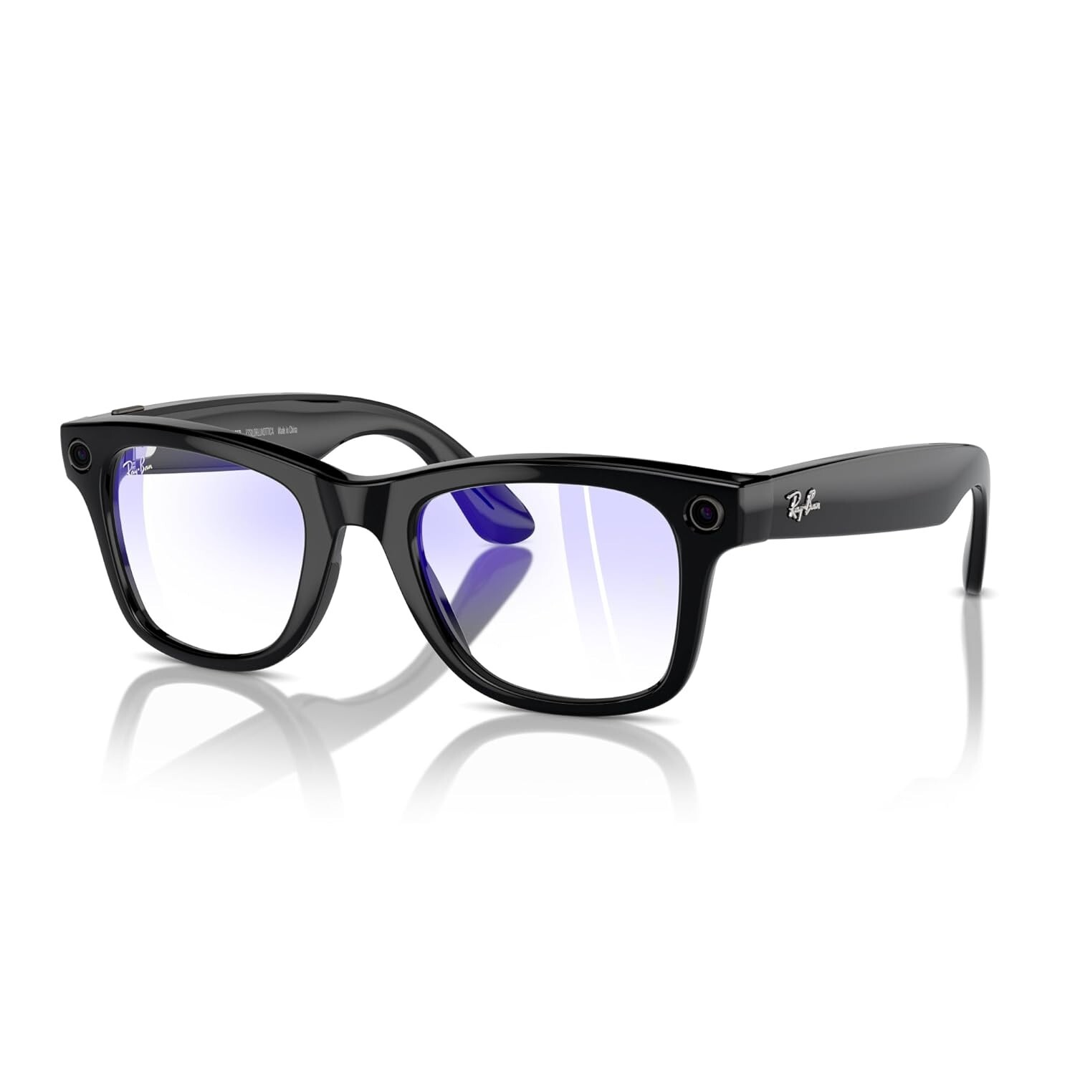
Figure 2.3: Ray-Ban Meta Smart Glasses in multiple styles.
(Source: The Verge product images)

Ray-Ban Meta Smart Glasses integrating a built-in camera, microphones, and open-ear speakers to enable voice-based AI interaction, live streaming, and social media content capture.

- Meta AI integration
- Voice-controlled assistant
- Built-in camera
- Live streaming support
- No indoor GPS or pathfinding
- No smart home dashboard
- No VR interaction
- Weak NLP action planning

Limitations:
Meta Smart Glasses provide strong social media integration but have no multimodal AI pipeline like the proposed system.

2.1.4 Indoor Navigation Apps (Google Maps Indoor, HERE Indoor Positioning)

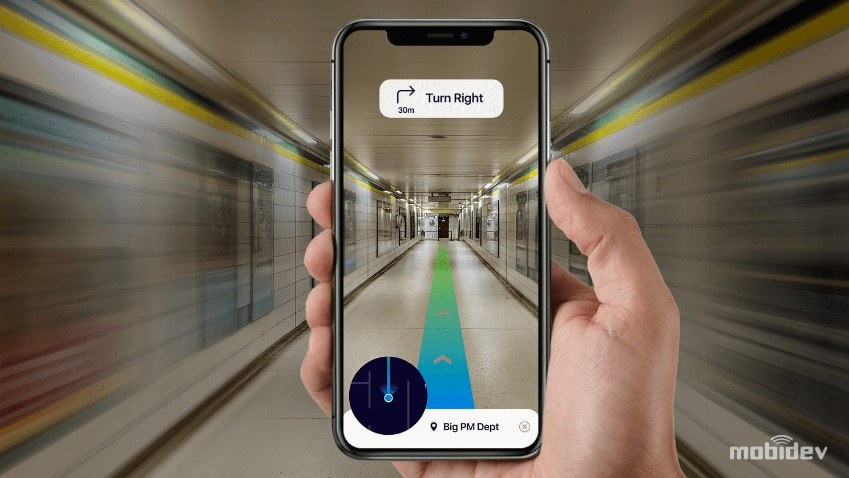
Figure 2.4: Mobidev guide on indoor navigation

Example of an indoor navigation interface showing floor-level routing and positioning inside a large commercial space.

Indoor navigation applications such as Google Maps Indoor and HERE Indoor Positioning are software-based solutions designed to guide users inside large commercial and public buildings. These systems extend traditional outdoor navigation by providing floor-level positioning and indoor route guidance.
- Provide floor-level guidance in commercial spaces.
- Require Wi-Fi fingerprinting or BLE beacons.
- Not suitable for custom buildings without dedicated infrastructure.

Limitations:
They cannot be embedded into wearable glasses and require expensive sensor setups.

2.1.5 Smart Home Systems (Google Home, Alexa, HomeKit)

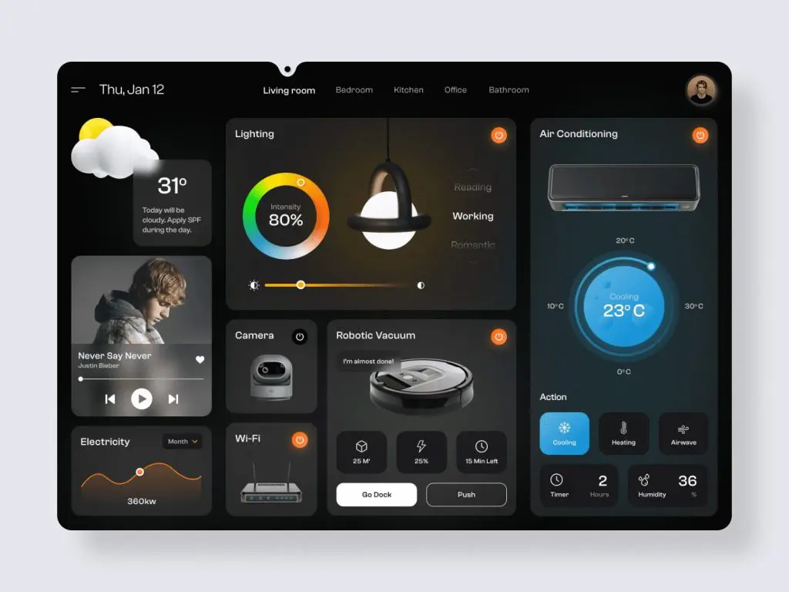
2.1.5 Smart Home Systems (Google Home, Alexa, HomeKit)

Example of a smart home control dashboard interface illustrating connected devices and settings accessible through smart home systems.

- Rely mainly on voice commands.
- No wearable integration.
- No AR or VR control interfaces.
- No customized device control or dashboards.

Overall Problems of Existing Systems
Across all competitors, several major limitations emerge:

2.2.1 Lack of Multimodal Interaction

Most systems either:

- Use speech only (Echo Frames)
- Use AR only (Google Glass)
- Or use AI only (Meta Glasses)

No existing system combines:
✔ Speech → Text → LLM → Action → AR/VR
✔ Real-time vision understanding
✔ Indoor navigation
✔ Smart home control
✔ Mobile + Web dashboards

2.2.2 No Indoor Navigation

Existing glasses rely on GPS, which:

- Fails indoors
- Cannot detect stairs/elevators/rooms
- Cannot be customized for small buildings
- This project solves the problem by:
- Creating a manual building map
- Converting it to a graph representation
- Using JSON path planning
- Supporting stairs, elevators, and corridors

2.2.3 Limited Hardware Capabilities

Market devices lack:

- Affordable microcontrollers
- Customizable sensors
- Full integration with apps
- Real-time speech processing locally

The proposed system uses:

- ESP32 with WiFi/Bluetooth
- Microphone + speakers
- On-device fast communication
- Direct connection with app and web

2.2.4 Weak NLP Reasoning

Most competitors do NOT turn user commands into structured actions.

Our project uses:

- MCB NLP pipeline
- Converts natural commands → steps → JSON → model execution
- Works with speech, vision, navigation, and smart home

2.2.5 No Computer Vision

Competitors rarely include:

- YOLO object detection
- Real-time local inference
- Custom dataset training

Our system uses:

- YOLO11
- Custom dataset
- Real-time feature extraction
- Object detection integrated with navigation

Comparison Between Existing and Proposed Method

Table 2.1: Comparison of methods
Feature | Amazon Echo Frames | Google Glass EE | Meta Glasses
  Indoor Nav Apps
  Proposed Smart Glasses
Computer Vision | ❌
  ❌ Limited
  ✔ Basic
  ❌
  ✔ YOLO11 (custom)
Indoor Navigation | ❌
  ❌
  ❌
  ✔ Only app-based
  ✔ Full indoor routing
Hardware Control | ❌ |  |  | ❌
  ❌
  ❌
  ✔ ESP32 integration
Smart Home |  |  |  | ❌
  Limited via Alexa
  ❌
  ❌
  ✔ Full dashboard
Speech Recognition | ✔ Alexa
  ✔ Basic
  ✔ Meta AI
  ✔
  ✔ Whisper multilingual
Text-to-Speech |  |  | ✔
  ✔
  ✔
  ❌
  ✔ Bilingual
LLM Reasoning
  Limited
  ❌
  Moderate
  ❌
  ✔ MCB + LLM pipeline
AR Interaction | ❌ | ✔
  ❌
  ❌
  ✔ AR / VR modes
 |  | Limited |  |  | ✔ Full customization
  Customization
  Very limited
  Very limited
  Medium

Table 2.2: Comparison of products

Category | Apple Vision Pro | Oppo Air Glass 3 | Xiaomi Wireless AR | Huawei Vision Glass | Meta Quest 3
Device Type | MR Headset | AR Glasses | AR Glasses (wireless) | Smart Display Glasses | Mixed Reality Headset
Price | $3,499+ | ~Estimated $800 | — | ~$430 | $499 (128GB)
Release Year | 2024–2025 | 2024 | 2023 Prototype | 2023 | 2023
Weight | 750–800 g + 353 g battery | ~50 g | 40–120 g | Lightweight | ~515 g
OS / Platform | visionOS | ColorOS (phone) | Xiaomi AR OS | N/A | Meta OS (Android-based)
CPU / Chipset | Apple M5 + R1 | Phone-based | Snapdragon XR2 | Phone-based | Snapdragon XR2 Gen 2
GPU | 10-core GPU | Phone GPU | Adreno | Phone GPU | Adreno 740
RAM | 16GB unified | — | — | — | —
Storage | 256–1TB | — | — | — | 128–512GB
Display Type | Micro-OLED | Waveguide | Micro-OLED waveguide | Micro-OLED | LCD + Pancake lenses
Resolution (per eye) | 23M pixels total | — | High PPD | 1080p | 2064×2208
Refresh Rate | 90/96/100/120 Hz | — | — | N/A | 120 Hz
Field of View | — | — | — | N/A | —
Brightness | — | 1000+ nits | ~1200 nits | High | —
Sensors | 14+ sensors: LiDAR, IMUs, eye tracking | Touch, mic | 3 cams + IMU | Basic | RGB/IR cams, depth
Cameras | Stereo 3D + passthrough | — | Tracking cams | — | 2 RGB + 4 IR
Tracking | Hand + eye + head | Basic | Hand + head | None | Inside-out 6DoF
Hand Tracking | Yes | Yes | Yes | No | Yes
Eye Tracking | Yes | No | No | No | No
Authentication | Optic-ID (iris) | — | — | — | —
Audio | Spatial Audio | On-ear speakers | Spatial audio | Stereo | 3D spatial
Battery | 2.5 h (external) | Unknown | Concept | None | 2–3 h
Charging | USB-C | — | — | USB-C | USB-C 3.2
Connectivity | Wi-Fi 6, BT 5.3 | BT, Wi-Fi | Wireless low-latency | USB-C | Wi-Fi 6E, BT
Input Methods | Eye/hand/voice | Touch | Hand/voice | Buttons | Controllers + hand
IPD Range | 51–75 mm | — | — | — | —
Use Cases | Full MR apps | Smart overlay | AR apps | Virtual screen | VR/MR gaming
Special Features | Spatial video, OpticID | High portability | Wireless AR | Cinema display | Full-color passthrough

Category | Magic Leap 2 | HoloLens 2 | Meta Ray-Ban Glasses | Lenovo ThinkReality A3 | VIVE XR Elite | Amazon Echo Frames (3rd Gen) | Amazon Amelia Smart Glasses (Best-Estimate) | Smart Glasses
Device Type | Enterprise AR Headset | Enterprise MR Headset | Smart Glasses | AR Tethered Glasses | XR Headset | Smart audio glasses (no AR display) | Enterprise AR smart glasses for delivery workers | Smart glasses (AR + sensor-rich wearable)
Price | $3,600–$5,500 | ~$3,500 | $299–$379 | $1,499 | $1,099 | ~$269 | Not announced (expected enterprise-rate ~$1,200–$1,800) | Estimated $200 (without EoS)
Release Year | 2022 | 2019 | 2023 | 2021 | 2023 | 2023 (3rd Gen) | 2025 | 2026
Weight | 260 g (headset) | 566 g | 48–50 g | 130 g | Modular, lightweight | ~31–36 g depending on lens type | 70–110 g EST. (glasses only; battery offloaded to vest) | 70–120 g
OS / Platform | Magic Leap OS | Windows Holographic | Meta firmware | Custom Android | Android XR | Amazon custom firmware | Custom Amazon OS (Android-based, estimated) | Linux (Raspberry Pi OS / other Linux distro)
CPU / Chipset | AMD Zen 2 + RDNA2 | Snapdragon 850 + HPU 2.0 | Qualcomm mobile SoC | PC/Phone CPU | Snapdragon XR2 | Low-power embedded audio chipset | Snapdragon XR1 / XR2-class (estimated) | Processor Server-based (PC offload)
GPU | RDNA2 | Adreno + HPU | Integrated | PC/phone GPU | Adreno 650 | None | Integrated Adreno GPU EST | Server-based (PC GPU)
RAM | 16GB | 4GB | — | PC RAM | 12GB | Not specified (low-power embedded RAM) | 2–4 GB EST. | 8 GB onboard + PC RAM
Storage | 256GB NVMe | 64GB | — | PC storage | 128GB | Not applicable | 32–64 GB onboard EST. | 128 GB onboard + PC storage
Display Type | Waveguide | Holographic waveguide | None | Micro-OLED | LCD + pancake | (no AR / no HUD) | Monocular or binocular micro-LED / micro-OLED HUD EST | TBD
Resolution (per eye) | 1440×1760 | 2048×1080 | — | 1920×1080 | 1920×1920 | — | 640×400 – 1280×720 | TBD
Refresh Rate | 120 Hz | 60 Hz | — | 60 Hz | 90 Hz | __
Field of View | 70° | 52° | — | ~40° | 110° | __ | 10–20° EST | TBD
Brightness | 20–2000 nits | ~500 nits | — | 200–400 nits | — | __ | 1000+ nits (for outdoor delivery use) EST | TBD
Sensors | 3 cams + depth + eye | Depth + IR eye tracking | IMU, touch, mics | IMU, tracking cams | Depth + RGB + IMU | Accelerometer | IMU (accelerometer + gyro) | IMU- Eye tracking-Stereo 3D-Touch- Microphone-Camera-Speaker-Bluetooth radio
Cameras | 12.6MP RGB + depth | RGB + depth | 12MP | 8MP RGB | 16MP RGB | None | based CV hazard detection
Tracking | SLAM + eye tracking | 6DoF + hand + eye | None | 6DoF | Inside-out 6DoF | Basic motion tracking (IMU only) | Type No full 6DoF; uses basic IMU + visual tracking for alignment EST. | TBD
Hand Tracking | Yes | Yes | No | Yes | Yes | No | None | Yes
Eye Tracking | Yes | Yes | No | No | No | No | None | Yes
Authentication | Iris ID | — | LED indicator only | — | — | __
Audio | Spatial | Spatial | Open-ear speakers | Stereo | Integrated speakers | Open-ear directional speakers (4-micro speaker array) | Small open-ear speakers or bone-conduction EST | Unknown
Battery | 3.5 h | 2–3 h | 3–4 h | Tethered | ~2 h (swap) | ~6 hours continuous playback / full day mixed use | Life 8–12 hours using vest battery pack | Life Unknown
Charging | USB-C | Fast charge | Case | USB-C | USB-C | ~2 hours | Time 1–2 hours for vest battery EST | USB-C
Connectivity | Wi-Fi 6, BT | Wi-Fi 5 | Bluetooth | USB-C tether | Wi-Fi 6E, BT | Proprietary charging cable | Bluetooth + Wi-Fi (tethered to vest/phone/hub) | Wi-Fi, Bluetooth, Wired (PC link)
Input Methods | Hand/eye/voice | Hand/eye | Voice/touch | Controller optional | Controllers | Voice (Alexa) | Vest-mounted controller + Voice commands | Eye, Hand, Voice, Touch, Buttons
IPD Range | — | Auto | — | — | 54–73 mm | __ | N/A (fixed HUD, no IPD adjustment) | TBD
Use Cases | Enterprise AR | Enterprise MR | Camera + audio | Enterprise workflows | XR gaming + MR |  | Delivery routing | Camera + Audio + Controller + AR
Special Features | Dynamic dimming, SLAM | Holo UI | Social capture | PC-class AR | Hot-swap battery | Auto-off when removed | Hazard detection, Privacy mode | Hot-swap battery

Below are the sub-sections that must appear inside Related Work because they directly support the technology foundation.

2.4 Computer Vision in Wearable Systems
Computer vision has been used in mobile and robotics systems, but rarely in smart glasses. Using YOLO11, the proposed solution provides:
- Feature extraction
- Object detection
- Identifying obstacles
- Enhancing indoor navigation
This improves:
- Safety
- Context awareness
- Accessibility for people of determination

2.5 Indoor Navigation Using Graph-Based Mapping
Traditional GPS fails indoors due to:
- No satellite visibility
- Weak signal penetration
- Multipath interference
Existing research shows that indoor navigation requires:
- Graph-based modeling
- Manual map digitization
- JSON-based routing
- Customized building layouts
Our system maps Building 2 (Computer Science Building) manually, converts rooms, stairs, and elevators into nodes and edges, and uses it for indoor navigation.

2.6 Hardware in Smart Glasses
Existing systems use expensive hardware. By contrast, ESP32 offers:
- Low cost
- WiFi/Bluetooth
- Compact size
- Easy integration with glasses
- Real-time communication
Microphone + speakers allow:
- Real-time speech capture
- Playback of TTS responses
- Audio feedback for navigation

2.7 Speech Recognition (Whisper) in Wearables
Whisper is used because:
- It supports Arabic and English
- High accuracy
- Can transcribe audio/video
- Converts speech to .txt file
- Works offline or online
This enables:
- Hands-free interaction
- Fast processing
- Reliable commands for LLM

2.8 Text-to-Speech Systems
TTS research shows bilingual support improves accessibility. Our system uses two voices:
- Arabic TTS
- English TTS
Smart Glasses decide the output voice depending on LLM language.
2.9 Large Language Models
LLMs like GPT and LLaMA transform commands into structured actions. They provide:
- Context-aware reasoning
- Intelligent decision making
- Multi-step interpretation
This is enhanced by the MCP NLP pipeline, which performs:
- Intent classification
- Task decomposition
- Action-to-JSON transformation
- Model execution routing

2.10 Smart Home Integration
Existing smart homes lack wearable integration.
Our system introduces:
- Mobile app dashboard
- Web dashboard
- Device management
- Controllers
- Logs
- Statistics
- AR/VR interaction
This unifies all control methods.

2.11 User Flow and Multimodal Interaction
Compared to existing products, our system includes:
- Natural speech → text → commands
- Vision-based alerts
- AR navigation
- App dashboards
- Web dashboards
This creates a consistent and intuitive experience.

METHODOLOGY

3.1. Requirement Analysis

3.1.1 Textual Requirements

Functional Requirements
- Real-time Object Detection
  - The system must detect objects using a custom-trained YOLO model.
  - The model should identify indoor landmarks (doors, elevators, room numbers, stairs, etc.).
- Indoor Navigation
  - The system must compute optimal paths inside Building 2 using a custom indoor map.
  - The system should provide turn-by-turn navigation visually in AR and via speech.
- Multimodal Speech Interaction
  - The glasses must capture audio and run Whisper for speech-to-text.
  - The extracted text should be processed by an LLM to provide intelligent responses.
- Smart Home & IoT Control
  - Users must be able to control home devices (lights, AC, door lock) through voice.
  - The ESP32 microcontroller must receive commands over Wi-Fi and trigger actuators.
- Multilingual Communication
  - The system must transcribe, translate, and generate speech output in real time.
- Mixed Reality Rendering
  - The AR module must render virtual arrows, labels, and icons anchored to detected objects.
- User-Friendly Interaction
  - Users can interact with the system through voice, gestures, or UI element

Non-Functional Requirements
- Performance
  - Object detection must run at ≥ 20 FPS.
  - Speech recognition latency must be ≤ 2 seconds.
- Accuracy
  - YOLO model accuracy must exceed 90% mAP.
  - Whisper transcription accuracy must exceed 95% for English and Arabic.
- Usability
  - The interface must be simple for visually impaired and hearing-impaired users.
- Reliability
  - The system should maintain stable operation for long sessions.
- Security
  - Device commands must be encrypted before being sent to the ESP32 module.
- Portability
  - The system should run on mobile devices and AR glasses.
    - Use Case Diagram

- THE USER INTERFACE OF A SMART HOME MANAGEMENT DASHBOARD
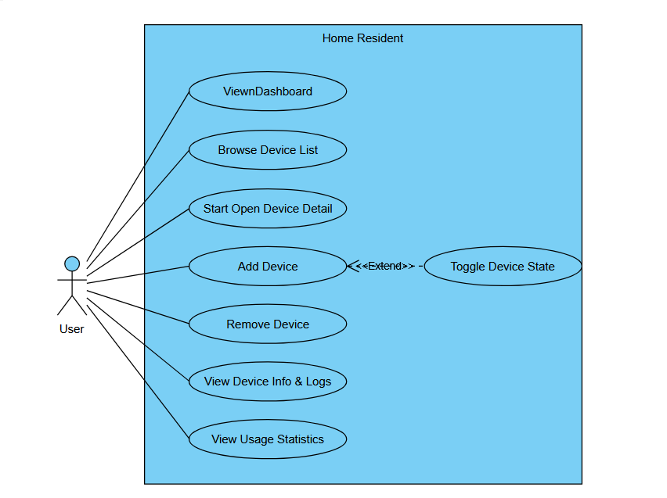
- Dashboard Overview: A central panel that allows the resident to monitor all connected devices at a glance.
- Device Management: Users can:
- Browse the list of connected smart devices
- Start or open device details for more controls
- Add new devices to the system
- Toggle device states (on/off)
- Remove devices
- Information & Analytics: Access to:
- Device information and activity logs
- Usage statistics for energy or performance tracking
- User Profile Section: Where the homeowner can manage account settings and preferences.
- This interface represents a centralized control system for IoT-based home automation, enabling users to efficiently monitor, control, and analyze their smart home devices from one platform.

- DEVICE LIFECYCLE MANAGEMENT
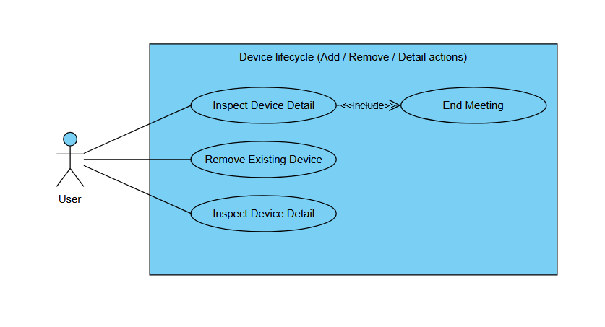
This use case diagram illustrates the Device Lifecycle Management process within the smart home system, outlining how users interact with devices through key operations: adding, inspecting, and removing devices. The diagram highlights the structured relationships between the primary actor (User) and the system functionalities.
- Key Components Explained:
Primary Actor:
- The User (resident or administrator) initiates all interactions with the smart home devices.
Main Use Cases:
Inspect Device Detail
- Allows the user to view detailed information about a specific device, such as status, logs, configuration, and real-time data.
Remove Existing Device
- Enables the user to permanently disconnect and delete a device from the system.
«include» Relationship
- The diagram shows that certain actions, such as concluding a device inspection session (End Meeting), are included as part of the main use cases, ensuring a complete and structured workflow.
Device Lifecycle Scope
- The process encompasses the complete lifespan of a device within the system—from addition and daily interaction through inspection, to eventual removal when no longer needed.
Purpose in the System:
- This structured lifecycle management ensures that users maintain full control over their smart devices, supporting scalability, usability, and system tidiness. By providing clear options to inspect details or remove devices, the system enhances user experience and operational efficiency.

- MONITORING & ANALYSIS DASHBOARD
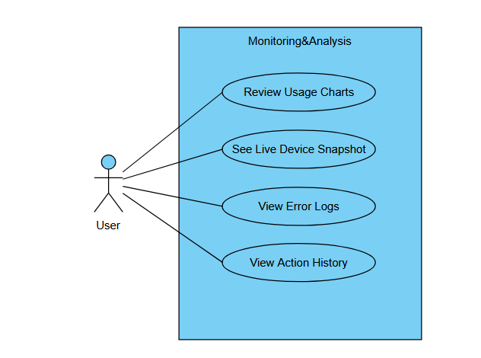
This use case diagram illustrates the Monitoring & Analysis capabilities of the smart home system, detailing how users interact with various data visualization and diagnostic tools to oversee their connected devices effectively.
- Key Components Explained:
Primary Actor:
- The User (homeowner or system administrator) who needs to monitor, analyze, and troubleshoot smart home device performance.
Main Use Cases:
Review Usage Charts
- Allows users to view graphical representations of device usage patterns, energy consumption trends, and historical performance data through interactive charts and graphs.
See Live Device Snapshot
- Provides real-time status overviews of all connected devices, showing current operational states, connection status, and immediate performance metrics.
View Error Logs
- Enables access to system-generated error reports and diagnostic logs, helping users identify technical issues, connectivity problems, or device malfunctions.
View Action History
- Displays chronological records of all user interactions with the system, including device activations, setting changes, and system modifications for audit and review purposes.
System Integration:
- All monitoring functions are interconnected through a unified dashboard interface that provides:
Centralized Data Visualization: Combining real-time and historical data in accessible formats
Proactive System Management: Early detection of issues through error monitoring
User Behavior Insights: Analysis of interaction patterns to optimize system usage
Troubleshooting Support: Comprehensive logs for technical diagnosis and maintenance
Purpose in the System:
- This monitoring and analysis module transforms raw device data into actionable intelligence, empowering users to make informed decisions about their smart home ecosystem. By providing both real-time oversight and historical analysis, the system promotes efficient energy usage, preventive maintenance, and optimized device performance while enhancing overall user control and system reliability.

- CONTROLLER PAIRING FLOW
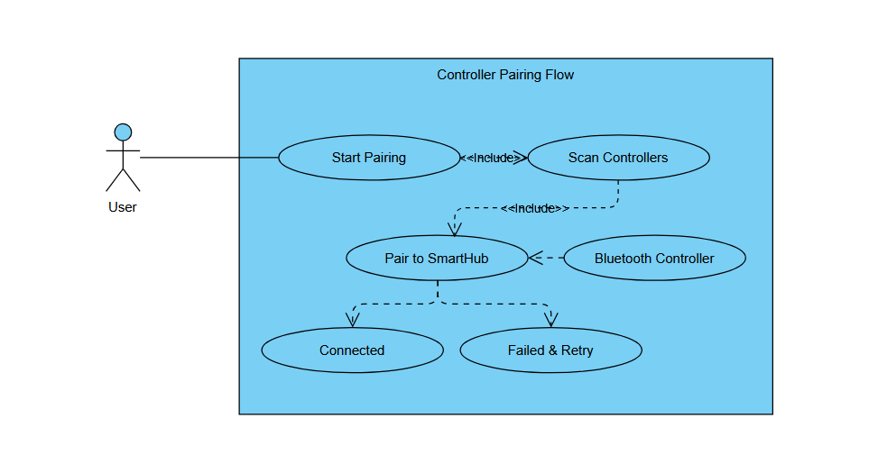
This use case diagram illustrates the Controller Pairing Flow process, detailing the steps a user follows to connect a Bluetooth-enabled controller to the smart home system via the central SmartHub.
- Key Components Explained:
Primary Actor:
- The User (system administrator or resident) who wants to add a new Bluetooth controller to their smart home network.
Main Use Cases:
- Start Pairing
- Initiates the device pairing mode within the smart home system, preparing it to discover and connect with new controllers.
Scan Controllers (Included use case)
- Automatically searches for nearby Bluetooth controllers that are in discoverable mode, displaying available devices to the user.
Pair to SmartHub (Included use case)
- Establishes a secure Bluetooth connection between the selected controller and the central SmartHub, enabling bidirectional communication.
Possible Outcomes:
Connected: Successful pairing confirmation, indicating the controller is now integrated into the system and ready for use.
Failed & Retry: An unsuccessful pairing attempt, with options to retry the connection process after troubleshooting.
Technical Workflow:
The user initiates the pairing process through the system interface.
The system scans for available Bluetooth controllers in the vicinity.
The user selects the desired controller from the discovered list.
The system attempts to establish a secure pairing with the SmartHub.
- Based on the result, the system either confirms a successful connection or prompts the user to retry the process.
System Requirements:
Bluetooth-enabled SmartHub with pairing capabilities
Compatible Bluetooth controller in discoverable mode
Adequate signal strength and proximity between devices
Proper authentication protocols for secure pairing
- Purpose in the System:
This standardized pairing flow ensures that users can seamlessly integrate new controllers into their smart home ecosystem with minimal technical knowledge. The structured process with clear success/failure states enhances user experience while maintaining system security and compatibility standards.
- DEVICE MANAGEMENT
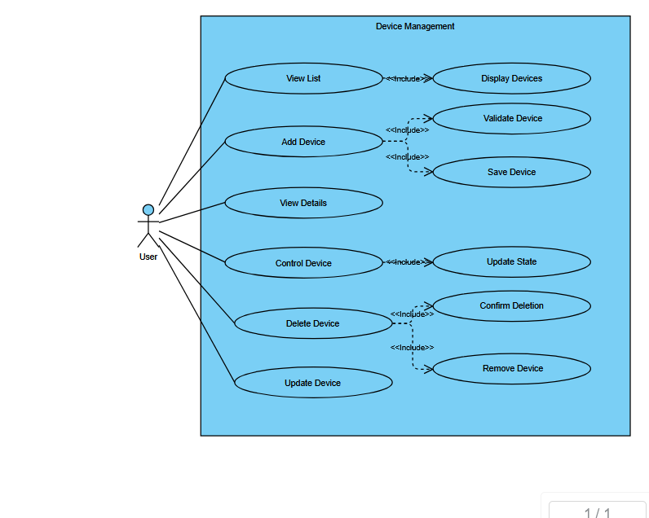
This use case diagram models the Device Management subsystem of the smart home platform. It defines how a user—typically a resident or administrator—interacts with IoT devices throughout their lifecycle, from discovery and registration to control, configuration, and removal.
- Key Components Explained:
Primary Actor:
- The User who manages smart home devices via a central interface (web or mobile).
Core Use Cases:
View List
- Retrieves and displays all registered devices in the system.
Includes: Display Devices – renders the device list in the UI.
Add Device
- Registers a new IoT device into the ecosystem.
Includes:
- Validate Device – ensures compatibility and credentials.
- Save Device – stores device metadata in the database.
View Details
- Shows detailed information about a selected device (status, specs, logs).
Control Device
- Sends commands to a device (e.g., on/off, mode change).
Includes: Update State – modifies and persists the device’s state.
Update Device
- Edits device properties such as name, location, or settings.
Delete Device
- Removes a device from the system.
Includes:
- Confirm Deletion – requires user confirmation.
- Remove Device – deletes the device record and cleans up associations.
- System Workflow & Relationships:
- The diagram uses «include» relationships to decompose high-level actions into reusable subprocesses. For example, Add Device always includes validation and persistence steps, ensuring consistency and data integrity. This modular approach supports maintainability and clear separation of concerns.
- Purpose in the System:
Device Management is foundational to the smart home platform—it enables users to:
- Onboard new devices seamlessly

- Monitor and control devices in real time
- Modify configurations as needs change
- Safely retire devices without system disruption
- By structuring these operations into distinct yet connected use cases, the system ensures a clear, intuitive, and error-resistant user experience while maintaining scalability and security.
- CONTROLLER MANAGEMENT
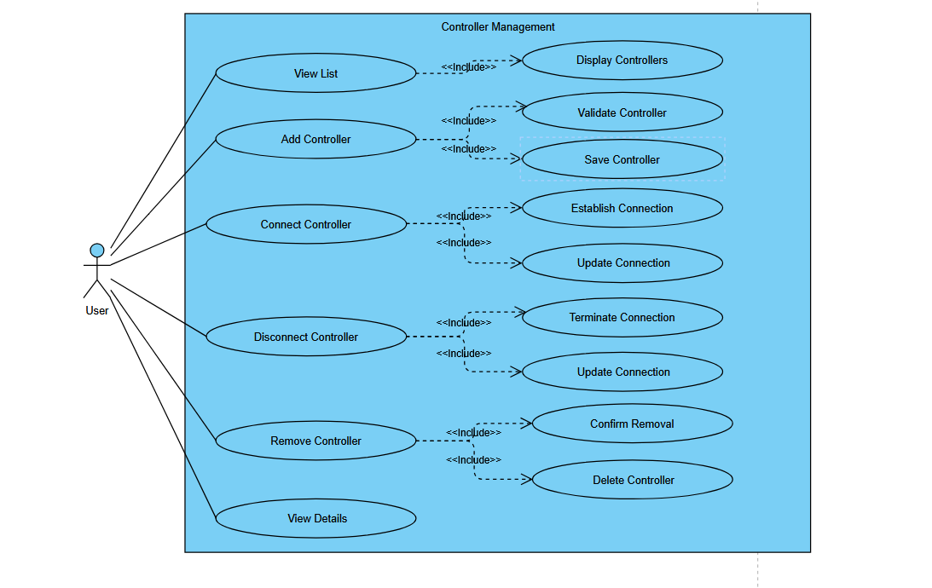
This use case diagram illustrates the Controller Management subsystem within the smart home system, detailing how users interact with and manage the various controllers that operate connected devices throughout the home.
- Key Components Explained:
Primary Actor:
- The User (homeowner or system administrator) responsible for managing smart home controllers.
Core Use Cases:
View List
- Displays all registered controllers in the system.
Includes: Display Controllers – renders the controller list in the user interface.
Add Controller
- Registers a new controller to the system.
Includes:
- Validate Controller – checks compatibility and credentials
- Save Controller – stores controller metadata in the database
- Establish Connection – initiates communication link with the controller
Connect Controller
- Activates an existing controller to make it operational.
Includes: Update Connection – modifies and persists the controller's connection status.
Disconnect Controller
- Temporarily deactivates a controller without removing it from the system.
Includes:
- Terminate Connection – safely ends the communication session
- Update Connection – records the disconnection status
Remove Controller
- Permanently deletes a controller from the system.
Includes:
- Confirm Removal – requires user confirmation to prevent accidental deletion
- Delete Controller – removes all controller data and associations
View Details
- Shows comprehensive information about a specific controller, including status, specifications, and activity history.
System Architecture & Relationships:
- The diagram employs «include» relationships to break down complex operations into reusable, atomic subprocesses. This modular design ensures:
Consistency: Common operations (like connection updates) are standardized across different use cases
Reliability: Validation and confirmation steps prevent errors and data corruption
Maintainability: Isolated subprocesses simplify debugging and feature updates
Technical Implementation:
- The controller management system handles multiple communication protocols (Bluetooth, Wi-Fi, Zigbee) and ensures:
- Secure authentication during controller addition
- Persistent connection state tracking
- Graceful disconnection and cleanup procedures
- Comprehensive logging of all controller interactions
Purpose in the System:
- Controller Management forms the backbone of device interoperability in the smart home ecosystem by:
Enabling Centralized Control – Allowing users to manage multiple controllers from a unified interface
Ensuring System Integrity – Validating and securing all controller connections
Providing Operational Flexibility – Supporting temporary disconnection and permanent removal as needed
Maintaining System Scalability – Facilitating easy addition of new controllers as the home network expands
- This structured approach to controller management ensures robust, secure, and user-friendly control over the entire smart home infrastructure while maintaining system stability and security standards.

- STATISTICS & ANALYTICS
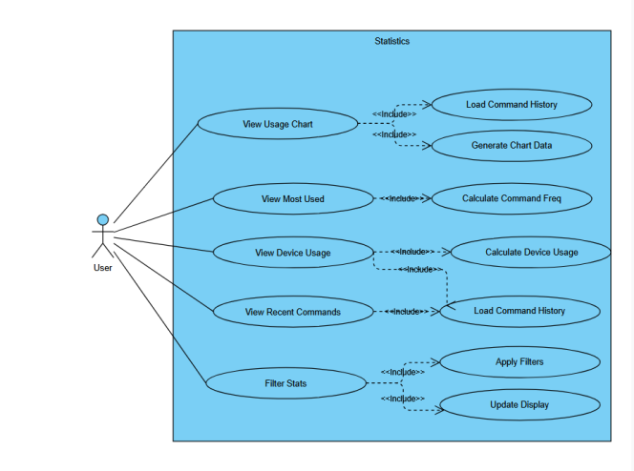
This use case diagram outlines the Statistics & Analytics module of the smart home system, which enables users to monitor, analyze, and derive insights from their home automation data through interactive charts, usage reports, and historical logs.

- Key Components Explained:
Primary Actor:
The User (resident, administrator, or homeowner) who wants to review system performance, usage patterns, and operational history.
Core Use Cases:
View Usage Chart
- Displays graphical representations of system and device usage over time.
Includes: Generate Chart Data – processes raw data into visualization-ready formats.

View Most Used
- Highlights the most frequently activated devices or commands.
Includes: Calculate Command Frequency – aggregates and ranks usage data.

View Device Usage
Shows detailed consumption and activity metrics for individual devices.
Includes: Calculate Device Usage – computes utilization statistics per device.

View Recent Commands
Lists the latest user-initiated actions and system events in chronological order.
Includes: Load Command History – retrieves recent logs from the database.

Filter Stats
Allows users to refine statistics by date range, device type, room, or other criteria.
Includes:
- Apply Filters – processes user-selected criteria
- Update Display – refreshes the interface with filtered results
System Architecture & Data Flow:
The module follows a data pipeline approach where:
Data Collection – Usage logs, command histories, and device states are continuously recorded
Data Processing – Calculations (frequency, totals, averages) are performed in real-time or on-demand
Data Visualization – Results are presented in user-friendly charts, lists, and dashboards
Data Interaction – Users can filter, drill down, and customize views
Technical Features:
- Real-Time Analytics: Live data processing for up-to-date insights
- Historical Reporting: Long-term trend analysis and comparison
- Interactive Visualizations: Zoom, filter, and export capabilities
- Automated Insights: Identification of usage patterns and anomalies
Purpose in the System:
- The Statistics & Analytics module transforms raw operational data into actionable intelligence by:
- Promoting Efficient Usage – Helping users identify energy-saving opportunities
- Enabling Proactive Maintenance – Detecting unusual patterns that may indicate device issues
- Supporting Informed Decisions – Providing data-driven insights for system optimization
- Enhancing User Awareness – Increasing transparency about home automation patterns
- Facilitating Reporting – Generating exportable reports for personal or professional review

- This comprehensive analytics solution ensures users maintain full visibility into their smart home operations, supporting both convenience and conscious consumption through data-driven insights.
- AUGMENTED REALITY (AR) DEVICE MANAGEMENT
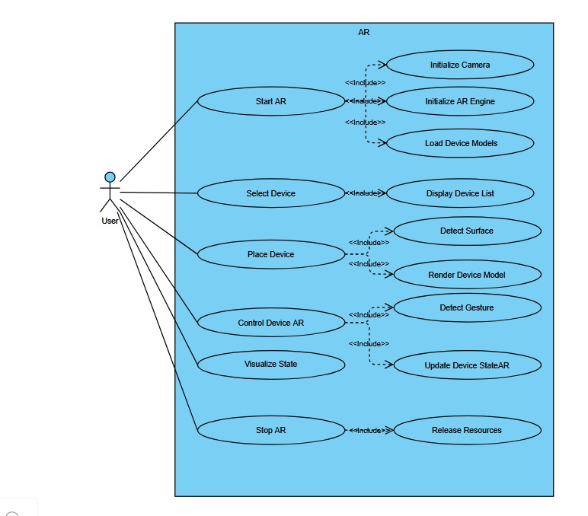
This use case diagram illustrates the Augmented Reality (AR) Device Management module, which allows users to interact with their smart home devices through an immersive AR interface. The system enables users to visualize, place, and control virtual representations of their devices in a real-world environment.
Primary Actor:
User: The homeowner or administrator who uses the AR application to manage smart devices.
Core Use Cases Explained:
- AR
- The main use case representing the overall AR experience.
Includes: Initialize Camera – Activates the device camera to capture the real-world environment.
Includes: Start AR – Launches the AR session and initializes the AR engine.
Includes: Initialize AR Engine – Prepares the AR framework (e.g., ARCore, ARKit) for tracking and rendering.
Includes: Load Device Models – Loads 3D models of smart devices into the AR scene.
Select Device
- Allows the user to choose a device from a list to place in AR.
Includes: Display Device List – Shows a list of available devices with icons and names.
Place Device
- Enables the user to position a virtual device in the real-world environment.
Includes: Detect Surface – Uses AR plane detection to identify suitable surfaces (e.g., floors, tables).
Includes: Render Device Model – Displays the 3D model of the device at the selected location.
Control Device AR
- Allows the user to interact with the virtual device to control the real device.
Includes: Detect Gesture – Recognizes user gestures (e.g., tap, swipe) for interaction.
Includes: Visualize State – Updates the AR visualization to reflect the device’s current state (e.g., on/off, brightness).
Includes: Update Device State – Sends control commands to the actual smart device via the backend.
- Stop AR
- Terminates the AR session and cleans up resources.
Includes: Release Resources – Frees up camera, AR engine, and 3D model resources.
System Workflow:
- The user launches the AR feature from the main application.
- The system initializes the camera and AR engine, then loads available device models.
- The user selects a device from the list and places it on a detected surface in the real world.
- The user interacts with the virtual device through gestures, triggering commands that affect the real device.
- The AR visualization updates in real-time to reflect device state changes.
- The user can stop the AR session, which releases all resources.
Technical Requirements:
AR-Compatible Device: Smartphone or tablet with support for ARCore (Android) or ARKit (iOS).
Stable Environment: Adequate lighting and textured surfaces for AR tracking.
Backend Integration: Connection to the smart home backend for real-time device control and state updates.
3D Asset Library: Optimized 3D models for all supported smart devices.
Purpose in the System:
This AR module enhances the user experience by providing an intuitive, spatial interface for device management. It bridges the gap between the digital and physical worlds, allowing users to interact with their smart home in a more natural and engaging way. Key benefits include:
Visual Context: See device locations and states in the actual environment.
Intuitive Control: Use gestures to control devices directly where they appear.
Enhanced Setup: Visually place virtual devices before purchasing or installing physical ones.
Immersive Monitoring: Monitor device status at a glance within the real-world context.
- UI-CONTROLLER INTERACTION FLOW FOR DEVICE MANAGEMENT
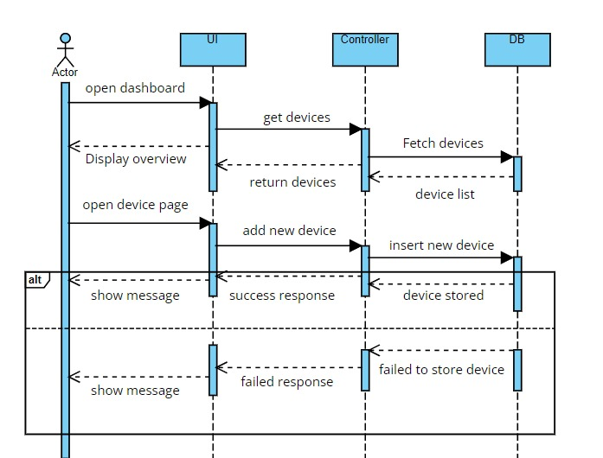
This diagram illustrates the sequence of interactions between the User Interface (UI) and the Controller layer during device management operations. It outlines the step-by-step communication flow when a user accesses the dashboard and attempts to add a new device to the system.
Components Explained:
- UI (User Interface)
- The frontend layer that the user interacts with.
- Responsible for displaying data, capturing user input, and sending requests to the backend.
Controller
- The backend layer that processes requests, interacts with the database, and returns responses to the UI.
- Handles business logic, data validation, and communication with the data storage layer.
Workflow Steps:
- Open Dashboard
- The user opens the smart home dashboard from the web or mobile application.
Fetch Devices
- The UI sends a request to the Controller to retrieve the list of registered devices.
Device List Returned
- The Controller queries the database and returns the list of devices to the UI.
Display Overview
- The UI renders the device list and dashboard overview for the user.
Add New Device
- The user initiates the process to add a new device through the UI.
Insert New Device
- The UI sends the new device details to the Controller for processing and storage.
Success Response
- If the device is successfully stored, the Controller returns a success message to the UI.
Failed Response
- If storage fails (due to validation errors, duplication, or system issues), the Controller returns an error message.
Error Handling & System Reliability:
- The flow includes clear success and failure pathways to ensure robust error handling.
- The UI is designed to respond appropriately to backend feedback, enhancing user experience and system transparency.
Purpose in the System:
This interaction model ensures a seamless, reliable, and user-friendly process for managing devices by:
Separating Concerns: Isolating frontend presentation from backend logic.
Ensuring Data Integrity: Validating and processing data centrally in the Controller.
Providing Real-Time Feedback: Keeping users informed through immediate success/error responses.
Supporting Scalability: Allowing the backend to handle multiple UI requests efficiently.
- DEVICE CONNECTION AND CONTROL FLOW
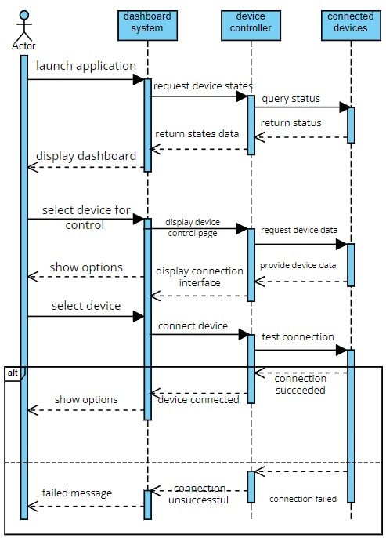
This diagram illustrates the system interaction flow between the user, the dashboard interface, the controller, and connected devices. It outlines the process from launching the application to successfully connecting and controlling a smart device, including error handling for failed connections.
Components and Roles:
User: Initiates actions through the application interface.
Dashboard System: Provides the user interface for monitoring and control.
Device Controller: Manages communication between the system and physical devices.
Connected Devices: Smart home devices (e.g., lights, sensors, appliances) that respond to commands.
Workflow Sequence:
Launch Application
- The user opens the smart home application, triggering an initial request to the system.
Request Device States
- The dashboard queries the controller for the current status of all registered devices.
Query Status & Return Status
- The controller checks each device's state and returns the information to the dashboard.
Display Dashboard
- The dashboard renders an overview showing all devices and their current statuses.
Select Device for Control
- The user chooses a specific device to interact with from the dashboard.
Display Device Control Page
- The system shows a dedicated control interface for the selected device.
Request Device Data
- The dashboard asks the controller for detailed data and available options for the device.
Show Options
- The device’s controllable parameters (e.g., on/off, brightness, mode) are displayed.
Display Connection Interface
- If the device is not connected, the system shows a connection interface.
Select Device & Connect Device
- The user selects the device and initiates the connection process.
Test Connection
- The system attempts to establish a communication link with the device.
Connection Successful
- If the connection is established, the system confirms and updates the device status to "connected."
Allow Control Options
- The user is now able to control the device through the provided options.
Connection Failed
- If the connection attempt fails, the system displays an error message ("connection unsuccessful") and may offer troubleshooting steps or a retry option.
System Reliability and User Feedback:
- The flow includes clear status updates at each stage, keeping the user informed.
- Immediate feedback is provided for both successful and failed operations.
- The system allows recovery actions (e.g., retry connection) in case of failure.
- Purpose in the System:
- This interaction model ensures a reliable and intuitive process for device management by:
- Providing Real-Time Status: Always showing the latest device states.
- Guiding User Actions: Leading the user step-by-step through connection and control.
- Handling Failures Gracefully: Offering clear error messages and recovery options.
- Ensuring Responsive Control: Minimizing latency between user commands and device responses.

- AUGMENTED REALITY (AR) SYSTEM ACTIVITY FLOW
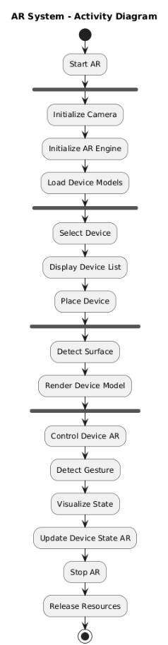This activity diagram illustrates the complete operational workflow of the Augmented Reality (AR) system within the smart home application. It details the sequential and parallel activities that occur from the moment the AR feature is initiated until it is terminated, providing a visual representation of the system's interactive process.
Activity Flow Description:
Start AR
- The user activates the AR mode from the main application interface, launching the augmented reality environment.
Initialize Camera
- The system activates the device's camera to capture the real-world environment for AR overlay and surface detection.
Initialize AR Engine
- The AR framework (e.g., ARCore for Android or ARKit for iOS) is initialized, setting up motion tracking, environmental understanding, and light estimation.
Load Device Models
- 3D models of smart home devices are loaded into memory from the asset library, preparing them for placement in the AR scene.
Select Device
- The user chooses a specific smart device from the available list to place in the AR environment.
Display Device List
- The system presents a scrollable list of device icons and names for user selection.
Place Device
- The user positions the selected virtual device in the real-world space through the AR interface.
Detect Surface
- The AR engine uses plane detection algorithms to identify flat surfaces (floors, tables, walls) suitable for device placement.
Render Device Model
- The 3D model of the selected device is rendered at the chosen location with proper scaling, lighting, and orientation.
Control Device AR
- The user interacts with the virtual device through gestures to control the actual smart device.
Detect Gesture
- The system recognizes and interprets user gestures (tap, swipe, pinch, etc.) as control commands.
Visualize State
- The AR representation updates in real-time to reflect the current state of the device (e.g., changing color for on/off status, adjusting brightness visualization).
Update Device State AR
- The system sends the corresponding control commands to the actual smart device through the backend API, synchronizing the physical device with its AR representation.
Stop AR
- The user exits the AR mode, terminating the augmented reality session.
Release Resources
- The system deallocates memory, stops the camera feed, and cleans up AR engine resources to optimize device performance.
Parallel Processing & System Optimization:
- Camera and AR Engine Initialization may occur concurrently for faster startup.
- Surface Detection continues running in the background during device placement for real-time environmental updates.
- Gesture Detection operates continuously while in AR mode to capture user interactions.
Error Handling & User Experience Considerations:
- If surface detection fails, the system prompts the user to move to a better-lit or more textured environment.
- If device models fail to load, the system displays placeholder objects with error indicators.
- If gesture recognition is ambiguous, the system provides visual feedback requesting clearer input.
- If device control commands fail, the AR visualization reverts to the previous state with an error notification.
Technical Requirements for Implementation:
Device Compatibility: AR-enabled smartphone/tablet with required sensors (gyroscope, accelerometer, RGB camera)
Minimum SDK Versions: iOS 11+ (ARKit) or Android 7.0+ (ARCore)
Processing Power: Sufficient GPU for real-time 3D rendering and scene processing
Memory Management: Efficient asset loading/unloading to prevent application crashes
Network Connectivity: Stable connection for real-time device state synchronization
Purpose in the System:
- This AR activity flow enhances the smart home management experience by:
- Providing Spatial Context: Allowing users to visualize devices in their actual physical environment
- Enabling Intuitive Interaction: Using natural gestures for device control rather than abstract button interfaces
- Supporting Planning and Simulation: Letting users experiment with device placement before physical installation
- Creating Immersive Monitoring: Offering a visually engaging way to monitor device status and relationships
- Reducing Cognitive Load: Presenting device controls in context rather than through hierarchical menus

- This comprehensive description of the AR system's activity flow is suitable for inclusion in your graduation project documentation under the "System Workflows" or "Use Case Specifications" section. It provides both technical details and user experience insights that demonstrate the sophisticated design of your AR integration.
- DASHBOARD WEB SESSION MANAGEMENT
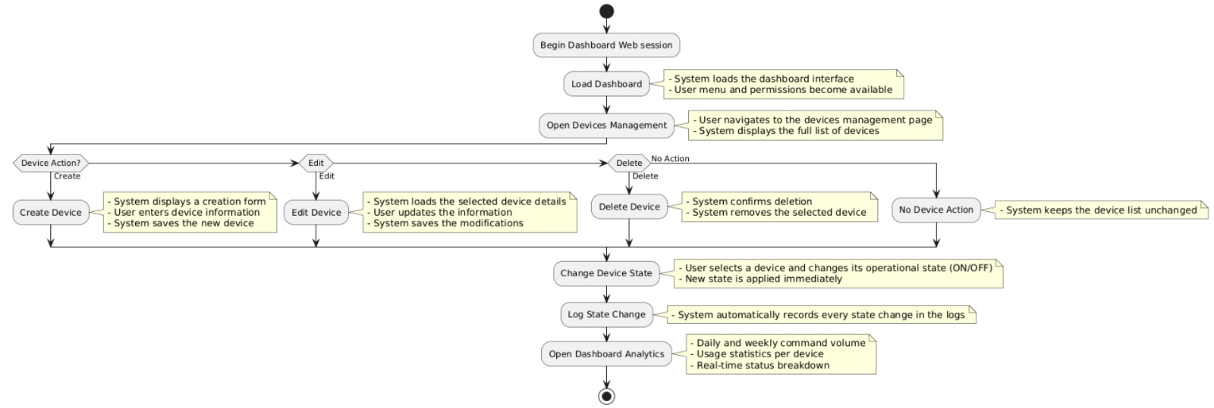
This use case diagram illustrates the complete workflow of a dashboard web session for a smart home management system. It outlines how users interact with the web interface to manage devices, monitor their status, and access analytical data through a structured, multi-step process.
Session Workflow Overview:
Begin Dashboard Web Session
- The system loads the dashboard interface with personalized user settings and layout preferences.
- User menu options and permission-based controls become available according to role and access level.
Open Devices Management
- User navigates to the dedicated devices management section.
- System retrieves and displays the complete list of registered devices with current status indicators.
Device Management Operations
Create Device:
- System presents a device creation form with required and optional fields.
- User inputs device information (name, type, location, specifications).
- System validates and saves the new device to the database.
Edit Device:
- User selects an existing device for modification.
- System loads the device's current details into an editable form.
- User makes updates and saves changes, which the system persists.
Delete Device:
- User initiates deletion of a selected device.
- System requests confirmation to prevent accidental removal.
- Upon confirmation, the device is permanently removed from the system.
Key Device Action:
- System maintains device list integrity during all operations, ensuring real-time consistency.
Change Device State
- User selects a specific device and toggles its operational state (ON/OFF, modes, settings).
- System immediately applies the new state and updates the device's physical or virtual status.
Log State Change
- System automatically records all state changes in the activity logs.
- Each entry includes timestamp, user ID, device ID, previous state, and new state for audit trails.
Open Dashboard Analytics
- User accesses the analytics dashboard for performance insights.
System displays:
- Daily and Weekly Command Volume: Activity frequency trends over time periods.
Usage Statistics per Device: Individual device utilization metrics and patterns.
Real-Time Status Breakdown: Current operational status distribution across all devices.
System Architecture Components:
Frontend Interface: Responsive web dashboard with dynamic components.
Backend Controller: Handles business logic, data processing, and API management.
Database Layer: Stores device information, user actions, and historical logs.
Real-Time Engine: Manages instant state updates and synchronization.
User Roles and Permissions:
Administrators: Full access to all management functions and analytics.
Standard Users: Limited to device control and basic viewing capabilities.
Guest Access: Read-only access to dashboard overview (configurable).
Technical Features:
Responsive Design: Dashboard adapts to different screen sizes (desktop, tablet, mobile).
Real-Time Updates: WebSocket connections for instantaneous state reflection.
Data Validation: Input validation and sanitization for all user submissions.
Session Management: Secure authentication and timeout protection.
Error Handling: Graceful error messages and recovery options.
Export Capabilities: Option to export analytics data in multiple formats (CSV, PDF).
Performance Metrics:
Page Load Time: < 2 seconds for initial dashboard load.
State Update Latency: < 100 milliseconds for device control operations.
Concurrent Users: Supports 1000+ simultaneous sessions.
Data Retention: Configurable log retention policies (default: 365 days).
Purpose in the System:
- This dashboard web session management system provides:
Centralized Control Hub: Single interface for all device management operations.
Operational Efficiency: Streamlined workflows for common device management tasks.
Transparent Monitoring: Clear visibility into system performance and device status.
Data-Driven Decisions: Analytics support for optimizing device usage and energy consumption.
Compliance and Auditing: Comprehensive logging for regulatory and troubleshooting purposes.
User Empowerment: Intuitive interface that reduces technical barriers to smart home management.
- This comprehensive dashboard system represents a professional-grade web interface for smart home management, combining functionality with usability while maintaining robust security and performance standards suitable for residential and small commercial applications.
- APPLICATION LIFECYCLE MANAGEMENT FLOW
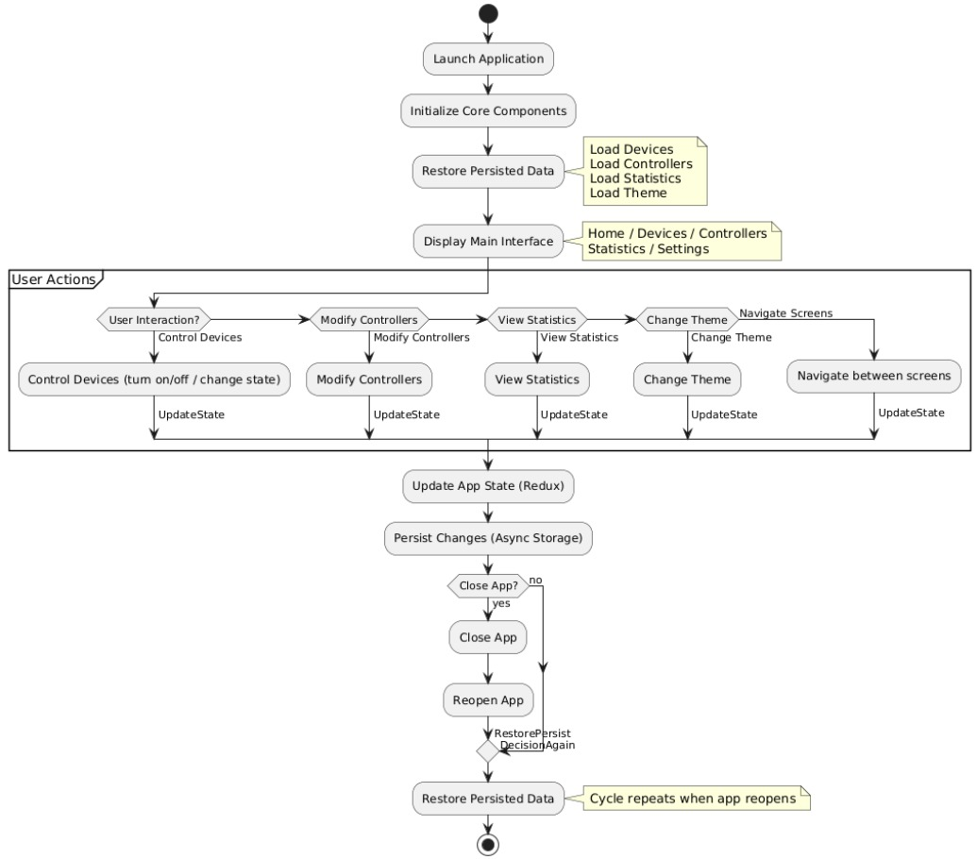
This activity diagram illustrates the complete application lifecycle of the smart home management system, from initial launch through user interactions, state management, and persistence. It demonstrates how the application maintains continuity across sessions while providing responsive user control over smart home devices and settings.
- Application Initialization Phase:
- Launch Application

- User initiates the application from the device's home screen or application launcher.
- Initialize Core Components

- System loads essential modules and prepares the runtime environment.

- Restore Persisted Data
- Application retrieves previously saved user data from local storage:
- Load Devices: Restores all registered smart devices with their last known states.
- Load Controllers: Recovers controller configurations and connection settings.
- Load Statistics: Retrieves historical usage data and analytics.
- Load Theme: Applies the user's preferred visual theme (light/dark mode, colors).

- Display Main Interface
- Presents the primary navigation dashboard with accessible sections:
- Home: Overview of current system status.
- Devices: Complete device management interface.
- Controllers: Controller pairing and configuration.
- Statistics: Usage analytics and reports.
- Settings: Application preferences and account management.

- User Interaction Loop:
- User Actions Detection
- System continuously monitors for user input through the interactive interface.

- Available User Interactions:
- Control Devices: Toggle device states (on/off), adjust settings, or trigger device-specific actions.
- Modify Controllers: Add, remove, or reconfigure device controllers.
- View Statistics: Access usage charts, historical data, and performance metrics.
- Change Theme: Switch between light/dark modes or customize interface appearance.
- Navigate Screens: Move between different application views and modules.

- State Update Processing
- Each user action triggers an UpdateState event that modifies the application's internal representation.

- State Management and Persistence:
- Update App State (Redux)
- The application uses Redux state management architecture to:
- Maintain a predictable, centralized application state.
- Enable time-travel debugging and state inspection.
- Support undo/redo functionality where applicable.
- Facilitate consistent state across different UI components.

- Persist Changes (Async Storage)
- State changes are automatically saved to persistent storage:
- Local Database: SQLite or similar for structured data.
- Async Storage: Key-value storage for quick access to preferences.
- File System: For larger data sets like logs or backup files.
- Persistence occurs asynchronously to prevent UI blocking.

- Application Termination and Restoration:
- Application Closure Decision
- User decides to close the application either explicitly or through system events.

- Graceful Shutdown
- Application ensures all pending writes are completed.
- Releases system resources and closes network connections.

- Reopening Application
- When user relaunches the application, the cycle restarts from Step 1.
- Persisted data is restored, maintaining continuity from the last session.

- Technical Architecture Components:

- State Management: Redux with middleware for side-effect handling.
- Persistence Layer: AsyncStorage with encryption for sensitive data.
- UI Framework: React Native or similar for cross-platform compatibility.
- Navigation: Stack-based navigation with tabbed interface.
- Theme Engine: Dynamic theming system supporting multiple visual schemes.
- Data Synchronization: Background sync with cloud services when available.

- Error Handling and Resilience:

- Data Corruption Recovery: Automatic backup restoration if primary data is corrupted.
- Network Interruption: Offline mode with queued operations for later sync.
- Memory Management: Automatic cleanup of unused resources.
- Crash Recovery: State restoration after unexpected application termination.

- Performance Optimization:
- Lazy Loading: Application components load on-demand to reduce initial startup time.
- Caching Strategy: Frequently accessed data cached in memory for rapid access.
- Debounced Updates: State persistence operations are batched to prevent excessive I/O.
- Background Processing: Non-critical operations performed in background threads.

- Security Considerations:
- Local Data Encryption: Sensitive information encrypted at rest.
- Secure State Transitions: Validation of all state changes to prevent unauthorized modifications.
- Session Management: Secure handling of authentication tokens and user sessions.
- Data Sanitization: Input validation and output encoding to prevent injection attacks.

- Purpose in the System:

- This application lifecycle management flow ensures:

- Seamless User Experience: Consistent interface state across application sessions.
- Data Integrity: Reliable persistence of user configurations and device states.
- Responsive Performance: Efficient state management for smooth UI interactions.
- Scalable Architecture: Foundation for adding new features and device types.
- Maintainable Codebase: Clear separation of concerns through Redux architecture.
- Cross-Platform Consistency: Uniform behavior across different operating systems.

    - Use Case Scenarios

UC1 – Real-Time Object Detection
Step | Description
1 | User starts camera mode.
2 | YOLO processes the current frame.
3 | Model returns detected objects + bounding boxes.
4 | AR module displays labels and icons.

UC2 – Indoor Navigation
Step | Description
1 | User gives voice command: “Guide me to Room 215.”
2 | Whisper → converts speech to text.
3 | LLM → extracts destination + context.
4 | Navigation engine computes shortest route.
5 | AR overlay provides arrows + callouts.

UC3 – Smart Home Control
Step | Description
1 | User says: “Turn on the lights.”
2 | STT module transcribes the request.
3 | LLM interprets command and creates a JSON instruction.
4 | System sends command to ESP32.
5 | Device activates the actuator.

3.2. Design
3.2.1. Activity Diagram
3.2.2. Class Diagram
Figure 3.1: Class Diagram of the Proposed Smart Glasses System
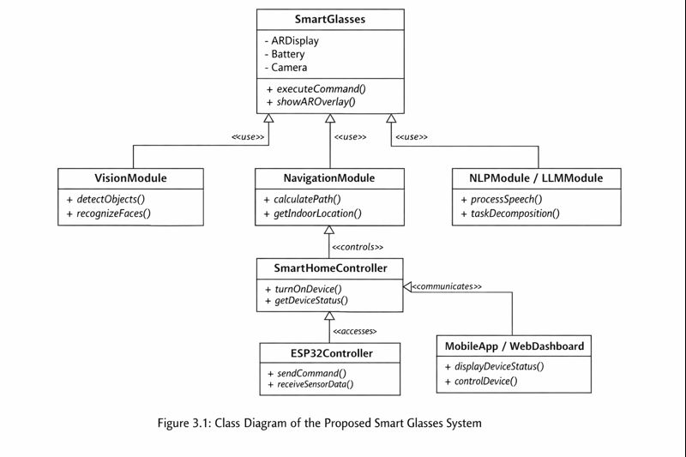
The diagram presents the main components of the Smart Glasses system and how they interact. The SmartGlasses class represents the device core, connecting with modules responsible for vision (VisionModule), navigation (NavigationModule), and language processing (NLPModule / LLMModule). The SmartHomeController oversees communication with IoT devices through the ESP32Controller, while the MobileApp / WebDashboard allows users to monitor and control the system. Each class is defined with its key attributes and methods, and the arrows indicate the relationships and interactions among the modules.

3.2.3. Deployment Diagram (and other UML diagrams if necessary)

3.3. Implementation
Main Technologies Used

- YOLOv11 for object detection

- OpenCV for camera streaming

- Whisper for speech recognition

- LLM API (OpenAI / local model)

- Unity / ARCore / ARKit for mixed reality rendering

- Python + Node.js backend

- ESP32 with MicroPython for IoT devices

3.4. Testing
- For Data/Model-driven Research Projects;

3.1. Overview of the Dataset/Model

3.2. Tools and Technology

3.3. Proposed Approach
- For System Design Projects;

3.1. Design Overview
3.2. System Architecture
The system follows a modular architecture consisting of six main modules:
- Vision Module (YOLO11 + Custom Dataset)
- Indoor Navigation Module (GPS + JSON-based Floor Map)
- NLP Pipeline (Whisper + LLM + Task Breakdown)
- Mixed Reality Interface (AR Overlay + VR Simulation)
- Smart Home Control Module
- Hardware Integration Layer (ESP32 + Sensors + Battery Unit)
Each module is loosely coupled and communicates through a central processing unit running the LLM and control logic.
3.3 Data Collection and Preparation

1. Vision Dataset Collection
- Dataset: custom images captured inside the Computer Science building.
- Classes: doors, stairs, elevators, signs, obstacles.
- Annotation Tool: Roboflow.
- Preprocessing: resizing, normalization, augmentation.

2. Floor Map Data for Indoor Navigation
- The building map was manually drawn.
- Converted into JSON format where each room, corridor, node, and path is represented by IDs.
- Applied graph representation for navigation (nodes, edges, weights).

3. Speech Dataset
- Whisper handles multilingual transcription.
- No manual data collection required.
3.4 Computer Vision Module

YOLO11 Model Training

We used YOLO11 due to its high speed, light weight, and strong accuracy in real-time environments.

Steps:

- Annotate images.

- Split into train/val/test.

- Train using transfer learning.

- Validate accuracy (mAP, precision, recall).

- Export ONNX version for real-time inference.

Why We Chose YOLO11

- Outperforms YOLOv8 in speed.

- Lightweight enough to run on portable devices.

- Excellent for object detection in dynamic environments.

3.5 Indoor Navigation Module

Creating the Navigation Graph

- Each corridor, hallway, and room is converted into nodes.

- Connections between nodes form edges with distances as weights.
- The result: a navigable graph.

Pathfinding Algorithm

- We apply A* because:

- It is faster than Dijkstra.

- Provides optimal paths.

- Works well for indoor map constraints.

3.6 NLP + LLM Reasoning Module

The NLP pipeline handles user speech, understands intent, breaks tasks into steps, and triggers actions.

Pipeline Flow

- Whisper converts speech → text.

- LLM analyzes the text.

- Task Breakdown Engine (MCB) converts the sentence into sub-steps.

- Action Manager decides what to trigger (navigation, smart home, CV, AR overlay).

- Output JSON defines system actions.

Why LLM?

- Understands natural language.

- Can perform reasoning.

- Handles complex commands like:

"Guide me to the AI lab and tell me if there are stairs on the way."
3.7 Mixed Reality (AR/VR Module)

AR Overlay

- Arrows are shown on the lenses.

- Based on navigation output.
- Highlights detected objects with bounding boxes.

VR Mode

Used for testing and for users with disabilities to simulate navigation.

3.8 Smart Home Automation Module

The smart glasses communicate with a Flask/FASTAPI backend.

Supported Features:

- Turn lights on/off

- Open/close smart door

- Adjust temperature

- Control appliances

3.9 Hardware Design and Integration

Components Used:

- ESP32 microcontroller

- Bone conduction speakers

- Dual microphones

- Ultra‑light camera

- Rechargeable battery pack

- Bluetooth/WiFi module

Why This Hardware

- Low power consumption

- Lightweight

- Supports real‑time streaming

- Affordable for a graduation project

3.10 System Workflow Summary

- User speaks command.

- Whisper transcribes it.

- LLM interprets and classifies the task.

- CV module or Navigation module activates.

- Output is displayed through AR overlay.

Smart home actions executed if needed.

3.11 Implementation Steps (Detailed)

- Collect Datasets (Vision + Map)
  - Identify the types of data required for the project: images for computer vision and maps for indoor navigation.
  - For vision datasets: collect images of objects, environments, or specific locations relevant to the use case. Include diverse conditions such as lighting variations, occlusions, and multiple angles to ensure model generalization.
  - For navigation datasets: obtain floor plans of buildings, including corridors, stairs, elevators, entrances, and exit points. If indoor GPS is not available, use manual measurements or mapping tools.
  - Ensure the dataset is comprehensive and representative to avoid bias in model performance.
- Prepare and Annotate Images
  - Clean and preprocess all collected images by resizing, normalizing, and correcting orientations.
  - Annotate objects using professional labeling tools (e.g., LabelImg, CVAT). Create bounding boxes, masks, or keypoints depending on the YOLO model requirements.
  - Maintain annotation consistency and define a clear labeling convention to reduce errors.
  - Split the dataset into training (70%), validation (15%), and test (15%) sets to ensure accurate model evaluation.
- Train YOLOv11 Model
  - Configure YOLOv11 architecture: define number of classes, anchor boxes, input dimensions, and backbone network.
  - Prepare the data pipeline to feed annotated images into the model efficiently, including data augmentation (rotation, scaling, flipping) to improve robustness.
  - Train the model on a GPU-enabled environment to speed up learning. Monitor training loss, precision, recall, and mAP (mean Average Precision) metrics.
  - Perform hyperparameter tuning such as learning rate, batch size, and epochs for optimal performance.
  - Test the trained model on the test set to evaluate generalization and fine-tune if necessary.
- Build Navigation Graph + JSON Map
  - Convert building floor plans into a graph structure where nodes represent key locations (rooms, intersections) and edges represent paths or connections.
  - Include details such as stairs, elevators, and corridors. Assign weights to edges to indicate distance or difficulty.
  - Encode the graph in JSON format, storing all nodes, edges, and metadata to allow the system to parse and compute navigation routes programmatically.
  - Implement pathfinding algorithms (e.g., Dijkstra or A*) to calculate the shortest and most efficient path to the target destination.
- Develop Whisper + LLM Pipeline
  - Integrate the Whisper speech-to-text engine to process audio inputs from the user.
  - Detect the spoken language (Arabic or English) automatically and transcribe the speech accurately.
  - Send the transcribed text to the Large Language Model (LLM) for semantic understanding and task planning.
  - Translate user commands into structured steps in JSON format for downstream execution by different modules (navigation, AR, smart home control).
  - Ensure error handling for misheard commands, ambiguous instructions, or unsupported requests.
- Implement AR Rendering
  - Develop the AR engine to overlay digital objects, navigation indicators, and notifications onto the real-world view captured by the glasses.
  - Integrate outputs from YOLO, GPS/IPS navigation, and environmental sensors to render accurate, real-time information.
  - Optimize frame rate and latency for smooth visualization in the Heads-Up Display (HUD).
  - Test AR overlays in multiple lighting and environmental conditions to ensure stability and reliability.
- Integrate ESP32 Hardware
  - Connect microphone, speaker, sensors, and other peripherals to the ESP32 microcontroller.
  - Establish wireless communication via Wi-Fi or Bluetooth between ESP32 and Smart Glasses for real-time data transfer.
  - Implement firmware to handle audio capture, playback, sensor reading, and command execution.
  - Ensure the hardware responds instantly to commands from both the user and the software modules.
- Test Modules Individually
  - Vision Module: Evaluate object detection accuracy and robustness using test images.
  - Navigation Module: Verify route calculation and indoor/outdoor navigation correctness.
  - Whisper + LLM Pipeline: Check transcription and command interpretation accuracy.
  - AR Rendering Module: Test overlay placement, HUD clarity, and AR responsiveness.
  - Hardware Module: Confirm microphone input, speaker output, and sensor readings are accurate.
  - Record results and debug any issues before integrating modules.
- Combine Modules for Full System
  - Integrate all modules into a single workflow to ensure seamless interaction between hardware and software.
  - Test communication between modules: commands from LLM should trigger navigation, AR, smart home actions, or media capture correctly.
  - Implement synchronization mechanisms and handle concurrency issues to prevent system crashes.
  - Perform end-to-end testing to ensure system stability and reliability under different use scenarios.
- Evaluate Performance
  - Define performance metrics:
    - YOLO detection accuracy
    - Speech recognition accuracy
    - Navigation precision
    - AR overlay responsiveness
    - Smart home command execution latency
  - Conduct real-world testing in multiple environments.
  - Identify bottlenecks and optimize system components where necessary.
  - Document results with screenshots, logs, and statistics to support evaluation.

3.3. System Software

EXPERIMENTAL RESULTS

DISCUSSION

CONCLUSIONS

REFERENCES

[1] Luo, Z., Shi, X., Lin, X., & Gao, J. (2025, April 15). Evaluation Report on MCP Servers. arXiv.

[2] Huang, B.-C., Hsu, J., Chu, E. T.-H., & Wu, H.-M. (2020). ARBIN: Augmented reality based indoor navigation system. Sensors, 20(20), 5890

[3] Alkady, Y., Rizk, R., Alsekait, D. M., Alluhaidan, A. S., & Abdelminaam, D. S. (2024). SINS_AR: An efficient smart indoor navigation system based on augmented reality. IEEE Access, 12, 109171–109183.

[4] Tepper, O. M., Rudy, H. L., Lefkowitz, A. B., Weimer, K. A., Marks, S. M., Stern, C. S., & Garfein, E. S. (2017). Mixed reality with HoloLens: Where virtual reality meets augmented reality in the operating room. Plastic and Reconstructive Surgery, 140(5), 1066–1070.

[5] Alla, M. (2025). Scalable MCP server-client architecture with FastMCP in microservices. Sarcouncil Journal of Multidisciplinary

[6] Singh, A., Ehtesham, A., Kumar, S., & Talaei Khoei, T. (2025). A survey of the Model Context Protocol (MCP): Standardizing context to enhance large language models (LLMs). arXiv.

[7] He, L.-H., Zhou, Y.-Z., Liu, L., Zhang, Y.-Q., & Ma, J.-H. (2025). Research on the directional bounding box algorithm of YOLO11 in tailings pond identification. Measurement, 253(Part C), 117674.

[8] Mastouri, M., Ksontini, E., & Kessentini, W. (2025). Making REST APIs agent-ready: From OpenAPI to MCP servers for tool-augmented LLMs. arXiv.

[9] Kelly, C., Hu, L., Yang, B., Tian, Y., Yang, D., Yang, C., Huang, Z., Li, Z., Hu, J., & Zou, Y. (2024). VisionGPT: Vision-language understanding agent using generalized multimodal framework. arXiv.

[10] C. Wang, W. Luo, S. Dong, X. Xuan, Z. Li, and L. Ma, “MLLM-Tool: A Multimodal Large Language Model for Tool Agent Learning,” in Proceedings of the 2025 IEEE/CVF Winter Conference on Applications of Computer Vision (WACV), Tucson, AZ, USA, Feb. 26–Mar. 6, 2025

[11] W. Berrios, G. Mittal, T. Thrush, D. Kiela, and A. Singh, “Towards Language Models That Can See: Computer Vision Through the LENS of Natural Language,” arXiv preprint arXiv:2306.16410, 2023.

[12] S. P. Samarth and S. B. Mahalingam, “The Gemma Sutras: Fine-Tuning Gemma 3 for Sanskrit Sandhi Splitting,” in Proceedings of the 9th Widening NLP Workshop (WiNLP), Association for Computational Linguistics, Suzhou, China, Nov. 2025, pp. 235–241

[13] Kopanov, K., & Atanasova, T. (2025). A comparative pattern analysis of Qwen 2.5 and Gemma 3 text generation. Institute of Information and Communication Technologies, Bulgarian Academy of Sciences.

[14] Wang, S., Yang, C.-H., Wu, J., & Zhang, C. (2024). Can Whisper perform speech-based in-context learning? In Proceedings of the 2024 IEEE International Conference on Acoustics, Speech and Signal Processing

[15] Yuan, J. (2024). Performance analysis of deep learning algorithms implemented using PyTorch in image recognition. Procedia Computer Science.

[16] Lei, X., Jiang, X., & Wang, C. (2013). Design and implementation of a real-time video stream analysis system based on FFMPEG. In 2013 Fourth World Congress on Software Engineering. IEEE.

[17] Hassler, D. M., Norbury, J. W., & Reitz, G. (2017). Mars science laboratory radiation assessment detector (MSL/RAD) modeling workshop proceedings. Life Sciences in Space Research, 14, 1–2.

[18] Amazon, “Echo Frames (3rd Gen) Smart Glasses,” Available: https://www.amazon.com/Echo-Frames-3rd-Gen-Smart-audio-glasses-with-Alexa-Modern-Rectangle-frames-in-charcoal-gray/dp/B09SVG2M7R

[19] Microsoft, “Microsoft HoloLens 2 Documentation,” Available: https://learn.microsoft.com/hololens/

[20] Meta, “Ray-Ban Meta Smart Glasses Official Announcement,” Available: https://about.fb.com/news/2023/09/new-ray-ban-meta-smart-glasses/

[21] Google, “Google Maps Indoor (Indoor Navigation),” Available: https://www.google.com/maps/about/partners/indoormaps/

[22] Google, “Google Home,” Available: https://home.google.com/welcome/

[23] Amazon, “Alexa Voice Assistant,” Available: https://www.amazon.com/alexa-voice-assistant

[24] HERE, “Indoor Positioning Documentation,” Available: https://developer.here.com/documentation/indoor-positioning/

[25]Apple, “Apple Home (HomeKit),” Available: https://www.apple.com/ios/home/
APPENDIX

Include additional content (raw data, code listing, etc.) as necessary to provide a detailed explanation that is not essential in the body of the report but that would be of interest of readers. If this section is not used, remove it from the project template. In case of having multiple appendix sections, informatively title and label as Appendix A, Appendix B, etc., according to the order in which they are mentioned in the text.

